SL.NO | FINANCIAL ASSISTANCE
1. | POST MATRIC SCHOLARSHIP FOR SC/ ST/ OBC
2. | MERIT- CUM- POVERTY STIPEND
3. | STIPEND FOR CHILDREN OF BUILDING AND OTHER CONSTRUCTION WORKER
4. | NORTH SOUTH FOUNDATION SCHOLARSHIP
5. | STIPEND FOR CHILDREN OF KENDU LEAVES COLLECTER
6. | TOPPERS MERIT SCHOLARSHIP
7. | SCHOLARSHIP FOR MINORITY CATEGORY THROUGH NSP
8. | WELFARE STIPEND TO STUDENTS IN CASE OF DEATH OF FINANCING GUARDIAN
9. | STIPEND FOR PHYSICALLY CHALLENGED STUDENTS THROUGH NSP(SAKSHYAM)
10 | STIPEND FOR GIRL CHILD THROUGH NSP(PRAGATI)
UNDER STUDENT CORNER
STUDENT WELFARE

Recognition
The institution is recognised by - AICTE
All Diploma courses are approved by - AICTE
Affiliated by - SCTE & VT (State Council for Technical Education and Vocational Training), Odisha Bhubaneswar
Institution is a member of Technical Professional Bodies like ISTE, IEI

RESULT
BRANCH | SESSION | PERCENTAGE
CIVIL | 2018-19 | 67
 | 2019-20 | 100
 | 2020-21 | 98
ELECTRICAL | 2018-19 | 72
 | 2019-20 | 93
 | 2020-21 | 95
MECHANICAL | 2018-19 | ----
 | 2019-20 | ----
 | 2020-21 | 97
E&TC | 2018-19 | 37
 | 2019-20 | 93
 | 2020-21 | 100
IT | 2018-19 | 86
 | 2019-20 | 100
 | 2020-21 | 92

MoU

Mou or Memorandum of Understanding is the agreement between the institute and industries to bring the two sides emotionally and strategically closer. To build good rapport between the industry and the institute, institutes should have memorandum of understanding (MOU) with the industries
This institute has signed MOU with
- MANSAROWER INDUSTRIES, ROURKELA
- L&T CONSTRUCTION SKILL & Training Center,Cuttack
- WATER KRAFT, HEALTH AND CARE ENTERPRISES, CHHEND COLONY, ROURKELA
- BLUE BIRD POWER CONTROL SYSTEM, CHHEND COLONY, ROURKELA
- KARZAM TECHNOLOGIES, PVT.LTD, ROURKELA
- SEENET CONSULTANCY SERVICES PVT.LTD, STPI COMPLEX, ROURKELA
- SEC WEIGHING MACHINE, INDUSTRIAL ESTATE, ROURKELA
- ROURKELA CONSTRUCTION PVT LTD. ROURKELA
- SWOSTI INFRASTRUCTURES PVT.LTD, ROURKELA
- ADHARSHILA ARCHITECTS ENGINEERS PVT.LTD
- REENA INDUSTRY PVT LTD, ROURKELA
- ORISSA ELECTRICALS PVT LTD, ROURKELA
- MANSAROWER INDUSTRIES, ROURKELA

STUDENT PROJECT PHOTO

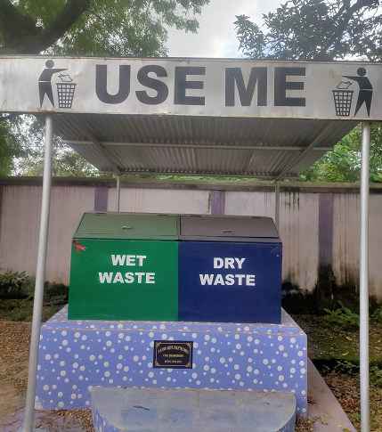

DUSTBIN PROJECT WORK OF CIVIL DEPARTMENT

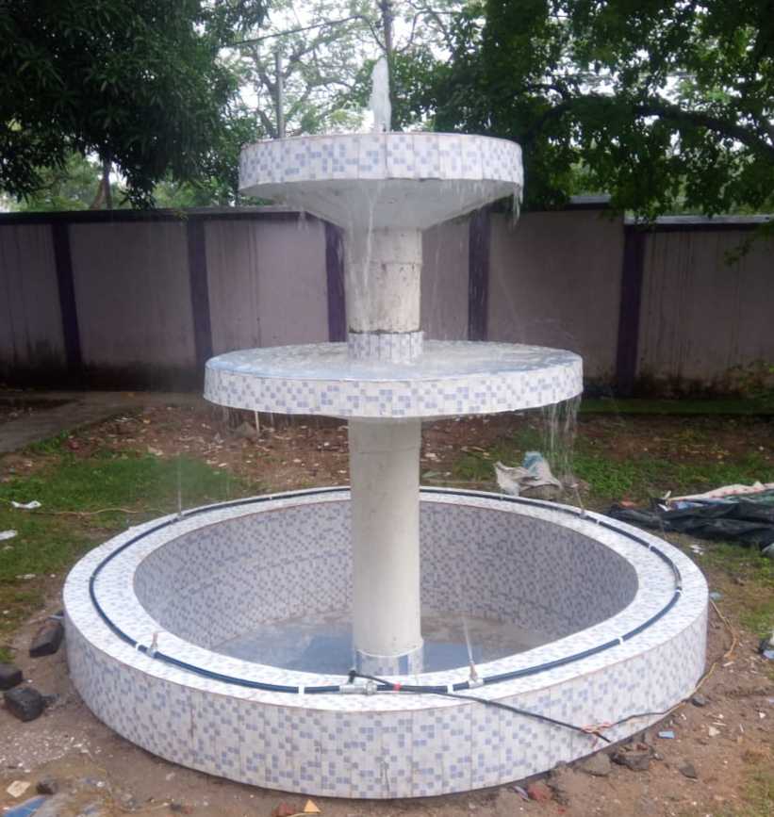
Fountain Project work of civil Department
Project work of ETC Department

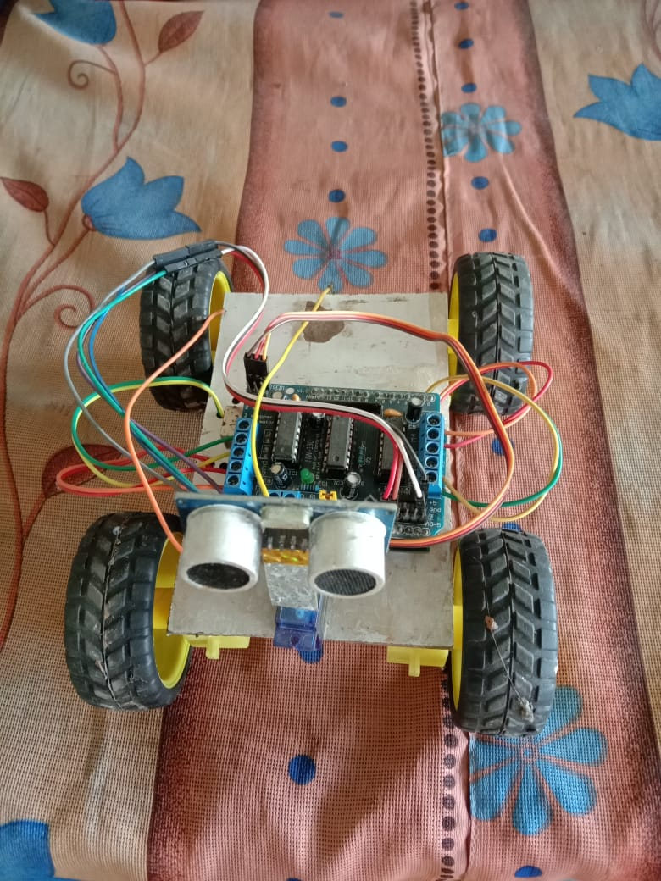
Obstacle avoiding car using Arduino

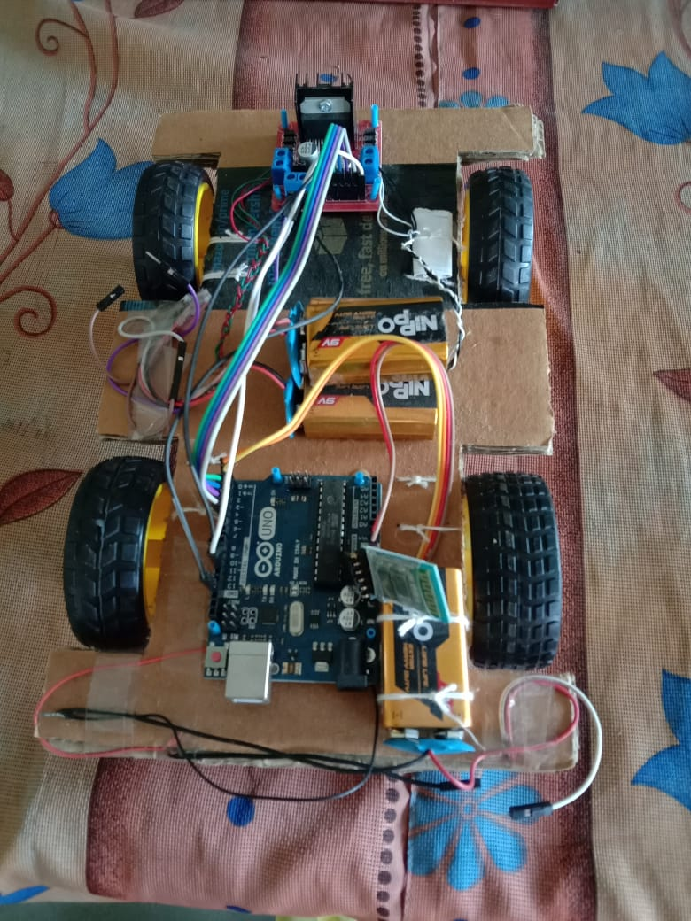
Bluetooth controlled Robot using Arduino

Project work of Electrical Department

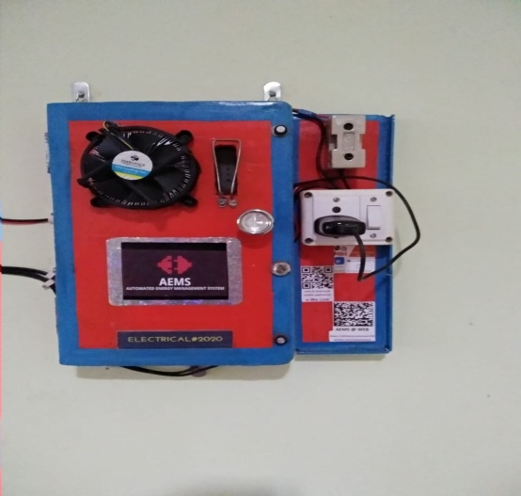
Automated Energy management system

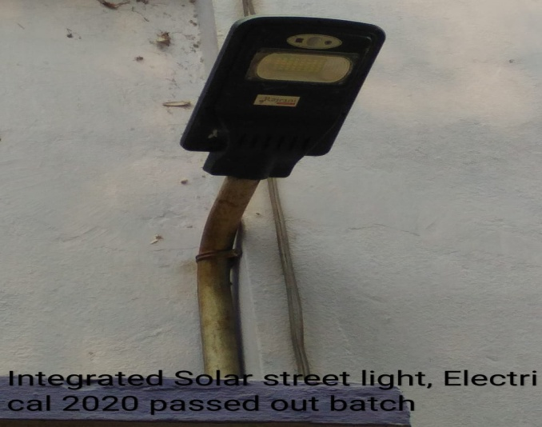

Project work of Information Technology
The Soul Tree | Online Shopping

PROJECT WORK OF MECHANICAL DEPARTMENT

