MODULE-3

Computer Network and Internet

Computer Network tutorial provides basic and advanced concepts of Data Communication & Networks (DCN). Our Computer Networking Tutorial is designed for beginners and professionals.
Our Computer Network tutorial includes all topics of Computer Network such as introduction, features, types of computer network, architecture, hardware, software, internet, intranet, website, LAN, WAN, etc.
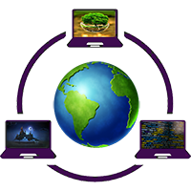

What is Computer Network?
A computer network is a set of devices connected through links. A node can be computer, printer, or any other device capable of sending or receiving the data. The links connecting the nodes are known as communication channels.
Computer Network uses distributed processing in which task is divided among several computers. Instead, a single computer handles an entire task, each separate computer handles a subset.

What is a Computer Network?
- Computer Network is a group of computers connected with each other through wires, optical fibres or optical links so that various devices can interact with each other through a network.
- The aim of the computer network is the sharing of resources among various devices.
- In the case of computer network technology, there are several types of networks that vary from simple to complex level.

OSI Model
- OSI stands for Open System Interconnection is a reference model that describes how information from a software application in one computer moves through a physical medium to the software application in another computer.
- OSI consists of seven layers, and each layer performs a particular network function.
- OSI model was developed by the International Organization for Standardization (ISO) in 1984, and it is now considered as an architectural model for the inter-computer communications.
- OSI model divides the whole task into seven smaller and manageable tasks. Each layer is assigned a particular task.
- Each layer is self-contained, so that task assigned to each layer can be performed independently.

Characteristics of OSI Model:
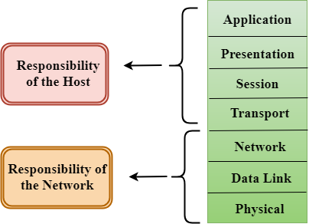
- The OSI model is divided into two layers: upper layers and lower layers.
- The upper layer of the OSI model mainly deals with the application related issues, and they are implemented only in the software. The application layer is closest to the end user. Both the end user and the application layer interact with the software applications. An upper layer refers to the layer just above another layer.
- The lower layer of the OSI model deals with the data transport issues. The data link layer and the physical layer are implemented in hardware and software. The physical layer is the lowest layer of the OSI model and is closest to the physical medium. The physical layer is mainly responsible for placing the information on the physical medium.

Functions of the OSI Layers
There are the seven OSI layers. Each layer has different functions. A list of seven layers are given below:
- Physical Layer
- Data-Link Layer
- Network Layer
- Transport Layer
- Session Layer
- Presentation Layer
- Application Layer
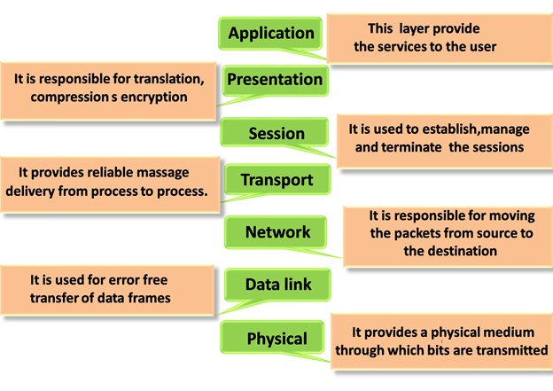

Physical layer
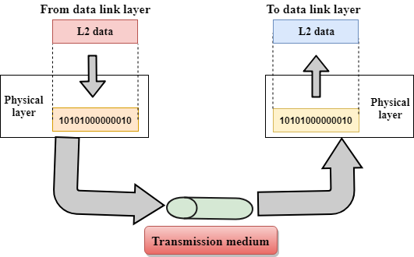
- The main functionality of the physical layer is to transmit the individual bits from one node to another node.
- It is the lowest layer of the OSI model.
- It establishes, maintains and deactivates the physical connection.
- It specifies the mechanical, electrical and procedural network interface specifications.

Functions of a Physical layer:
- Line Configuration: It defines the way how two or more devices can be connected physically.
- Data Transmission: It defines the transmission mode whether it is simplex, half-duplex or full-duplex mode between the two devices on the network.
- Topology: It defines the way how network devices are arranged.
- Signals: It determines the type of the signal used for transmitting the information.

Data-Link Layer
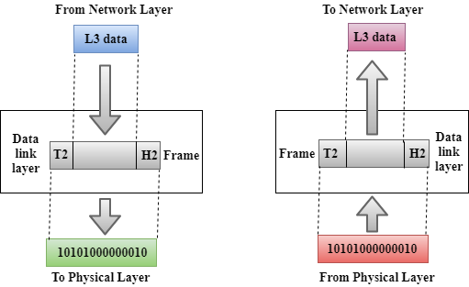
- This layer is responsible for the error-free transfer of data frames.
- It defines the format of the data on the network.
- It provides a reliable and efficient communication between two or more devices.
- It is mainly responsible for the unique identification of each device that resides on a local network.
- It contains two sub-layers:
  - Logical Link Control Layer
    - It is responsible for transferring the packets to the Network layer of the receiver that is receiving.
    - It identifies the address of the network layer protocol from the header.
    - It also provides flow control.
  - Media Access Control Layer
    - A Media access control layer is a link between the Logical Link Control layer and the network's physical layer.
    - It is used for transferring the packets over the network.

Functions of the Data-link layer
- Framing: The data link layer translates the physical's raw bit stream into packets known as Frames. The Data link layer adds the header and trailer to the frame. The header which is added to the frame contains the hardware destination and source address.
- Physical Addressing: The Data link layer adds a header to the frame that contains a destination address. The frame is transmitted to the destination address mentioned in the header.
- Flow Control: Flow control is the main functionality of the Data-link layer. It is the technique through which the constant data rate is maintained on both the sides so that no data get corrupted. It ensures that the transmitting station such as a server with higher processing speed does not exceed the receiving station, with lower processing speed.
- Error Control: Error control is achieved by adding a calculated value CRC (Cyclic Redundancy Check) that is placed to the Data link layer's trailer which is added to the message frame before it is sent to the physical layer. If any error seems to occurr, then the receiver sends the acknowledgment for the retransmission of the corrupted frames.
- Access Control: When two or more devices are connected to the same communication channel, then the data link layer protocols are used to determine which device has control over the link at a given time.

Network Layer
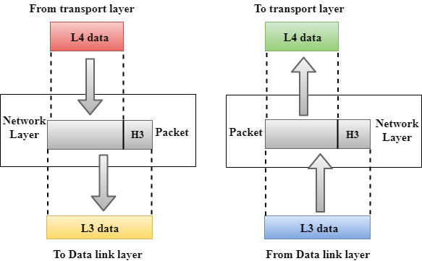
- It is a layer 3 that manages device addressing, tracks the location of devices on the network.
- It determines the best path to move data from source to the destination based on the network conditions, the priority of service, and other factors.
- The Data link layer is responsible for routing and forwarding the packets.
- Routers are the layer 3 devices, they are specified in this layer and used to provide the routing services within an internetwork.
- The protocols used to route the network traffic are known as Network layer protocols. Examples of protocols are IP and Ipv6.

Functions of Network Layer:
- Internetworking: An internetworking is the main responsibility of the network layer. It provides a logical connection between different devices.
- Addressing: A Network layer adds the source and destination address to the header of the frame. Addressing is used to identify the device on the internet.
- Routing: Routing is the major component of the network layer, and it determines the best optimal path out of the multiple paths from source to the destination.
- Packetizing: A Network Layer receives the packets from the upper layer and converts them into packets. This process is known as Packetizing. It is achieved by internet protocol (IP).

Transport Layer
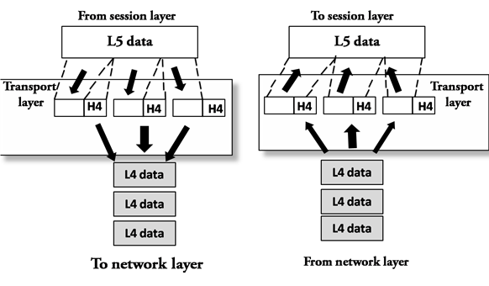
- The Transport layer is a Layer 4 ensures that messages are transmitted in the order in which they are sent and there is no duplication of data.
- The main responsibility of the transport layer is to transfer the data completely.
- It receives the data from the upper layer and converts them into smaller units known as segments.
- This layer can be termed as an end-to-end layer as it provides a point-to-point connection between source and destination to deliver the data reliably.
The two protocols used in this layer are:
- Transmission Control Protocol
  - It is a standard protocol that allows the systems to communicate over the internet.
  - It establishes and maintains a connection between hosts.
  - When data is sent over the TCP connection, then the TCP protocol divides the data into smaller units known as segments. Each segment travels over the internet using multiple routes, and they arrive in different orders at the destination. The transmission control protocol reorders the packets in the correct order at the receiving end.
- User Datagram Protocol
  - User Datagram Protocol is a transport layer protocol.
  - It is an unreliable transport protocol as in this case receiver does not send any acknowledgment when the packet is received, the sender does not wait for any acknowledgment. Therefore, this makes a protocol unreliable.

Functions of Transport Layer:
- Service-point addressing: Computers run several programs simultaneously due to this reason, the transmission of data from source to the destination not only from one computer to another computer but also from one process to another process. The transport layer adds the header that contains the address known as a service-point address or port address. The responsibility of the network layer is to transmit the data from one computer to another computer and the responsibility of the transport layer is to transmit the message to the correct process.
- Segmentation and reassembly: When the transport layer receives the message from the upper layer, it divides the message into multiple segments, and each segment is assigned with a sequence number that uniquely identifies each segment. When the message has arrived at the destination, then the transport layer reassembles the message based on their sequence numbers.
- Connection control: Transport layer provides two services Connection-oriented service and connectionless service. A connectionless service treats each segment as an individual packet, and they all travel in different routes to reach the destination. A connection-oriented service makes a connection with the transport layer at the destination machine before delivering the packets. In connection-oriented service, all the packets travel in the single route.
- Flow control: The transport layer also responsible for flow control but it is performed end-to-end rather than across a single link.
- Error control: The transport layer is also responsible for Error control. Error control is performed end-to-end rather than across the single link. The sender transport layer ensures that message reach at the destination without any error.

Session Layer
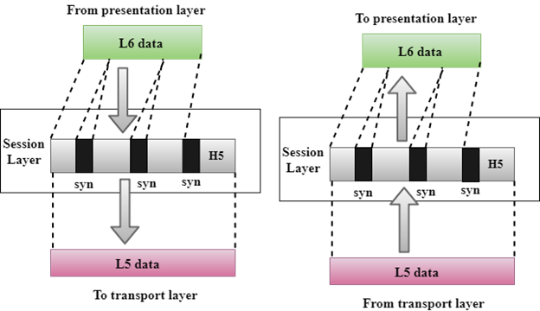
- It is a layer 3 in the OSI model.
- The Session layer is used to establish, maintain and synchronizes the interaction between communicating devices.

Functions of Session layer:
- Dialog control: Session layer acts as a dialog controller that creates a dialog between two processes or we can say that it allows the communication between two processes which can be either half-duplex or full-duplex.
- Synchronization: Session layer adds some checkpoints when transmitting the data in a sequence. If some error occurs in the middle of the transmission of data, then the transmission will take place again from the checkpoint. This process is known as Synchronization and recovery.

Presentation Layer
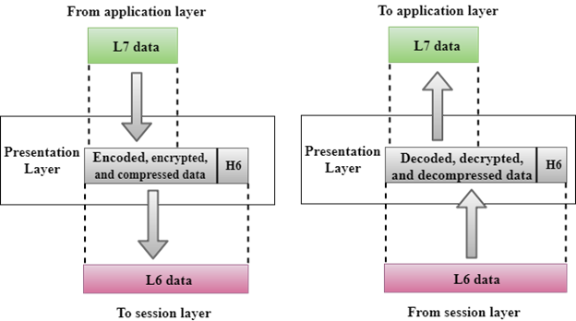
- A Presentation layer is mainly concerned with the syntax and semantics of the information exchanged between the two systems.
- It acts as a data translator for a network.
- This layer is a part of the operating system that converts the data from one presentation format to another format.
- The Presentation layer is also known as the syntax layer.

Functions of Presentation layer:
- Translation: The processes in two systems exchange the information in the form of character strings, numbers and so on. Different computers use different encoding methods, the presentation layer handles the interoperability between the different encoding methods. It converts the data from sender-dependent format into a common format and changes the common format into receiver-dependent format at the receiving end.
- Encryption: Encryption is needed to maintain privacy. Encryption is a process of converting the sender-transmitted information into another form and sends the resulting message over the network.
- Compression: Data compression is a process of compressing the data, i.e., it reduces the number of bits to be transmitted. Data compression is very important in multimedia such as text, audio, video.

Application Layer
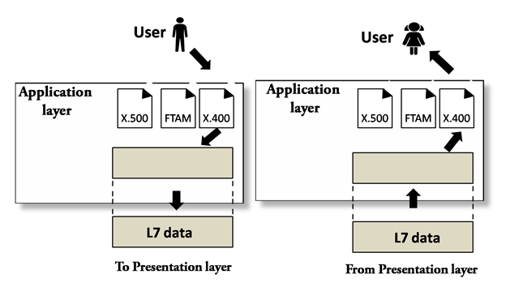
- An application layer serves as a window for users and application processes to access network service.
- It handles issues such as network transparency, resource allocation, etc.
- An application layer is not an application, but it performs the application layer functions.
- This layer provides the network services to the end-users.

Functions of Application layer:
- File transfer, access, and management (FTAM): An application layer allows a user to access the files in a remote computer, to retrieve the files from a computer and to manage the files in a remote computer.
- Mail services: An application layer provides the facility for email forwarding and storage.
- Directory services: An application provides the distributed database sources and is used to provide that global information about various objects.

TCP/IP model
- The TCP/IP model was developed prior to the OSI model.
- The TCP/IP model is not exactly similar to the OSI model.
- The TCP/IP model consists of five layers: the application layer, transport layer, network layer, data link layer and physical layer.
- The first four layers provide physical standards, network interface, internetworking, and transport functions that correspond to the first four layers of the OSI model and these four layers are represented in TCP/IP model by a single layer called the application layer.
- TCP/IP is a hierarchical protocol made up of interactive modules, and each of them provides specific functionality.
Here, hierarchical means that each upper-layer protocol is supported by two or more lower-level protocols.

Functions of TCP/IP layers:
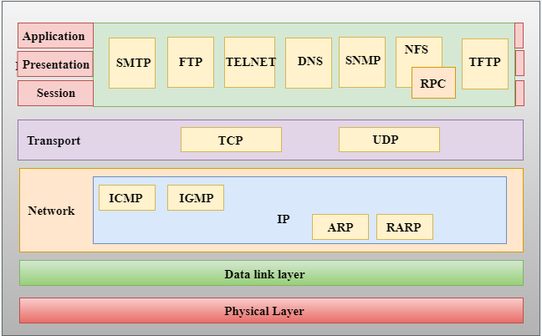

Network Access Layer
- A network layer is the lowest layer of the TCP/IP model.
- A network layer is the combination of the Physical layer and Data Link layer defined in the OSI reference model.
- It defines how the data should be sent physically through the network.
- This layer is mainly responsible for the transmission of the data between two devices on the same network.
- The functions carried out by this layer are encapsulating the IP datagram into frames transmitted by the network and mapping of IP addresses into physical addresses.
- The protocols used by this layer are ethernet, token ring, FDDI, X.25, frame relay.

Internet Layer
- An internet layer is the second layer of the TCP/IP model.
- An internet layer is also known as the network layer.
- The main responsibility of the internet layer is to send the packets from any network, and they arrive at the destination irrespective of the route they take.

Following are the protocols used in this layer are:
IP Protocol: IP protocol is used in this layer, and it is the most significant part of the entire TCP/IP suite.
Following are the responsibilities of this protocol:
- IP Addressing: This protocol implements logical host addresses known as IP addresses. The IP addresses are used by the internet and higher layers to identify the device and to provide internetwork routing.
- Host-to-host communication: It determines the path through which the data is to be transmitted.
- Data Encapsulation and Formatting: An IP protocol accepts the data from the transport layer protocol. An IP protocol ensures that the data is sent and received securely, it encapsulates the data into message known as IP datagram.
- Fragmentation and Reassembly: The limit imposed on the size of the IP datagram by data link layer protocol is known as Maximum Transmission unit (MTU). If the size of IP datagram is greater than the MTU unit, then the IP protocol splits the datagram into smaller units so that they can travel over the local network. Fragmentation can be done by the sender or intermediate router. At the receiver side, all the fragments are reassembled to form an original message.
- Routing: When IP datagram is sent over the same local network such as LAN, MAN, WAN, it is known as direct delivery. When source and destination are on the distant network, then the IP datagram is sent indirectly. This can be accomplished by routing the IP datagram through various devices such as routers.
ARP Protocol
- ARP stands for Address Resolution Protocol.
- ARP is a network layer protocol which is used to find the physical address from the IP address.
- The two terms are mainly associated with the ARP Protocol:
  - ARP request: When a sender wants to know the physical address of the device, it broadcasts the ARP request to the network.
  - ARP reply: Every device attached to the network will accept the ARP request and process the request, but only recipient recognize the IP address and sends back its physical address in the form of ARP reply. The recipient adds the physical address both to its cache memory and to the datagram header
ICMP Protocol
- ICMP stands for Internet Control Message Protocol.
- It is a mechanism used by the hosts or routers to send notifications regarding datagram problems back to the sender.
- A datagram travels from router-to-router until it reaches its destination. If a router is unable to route the data because of some unusual conditions such as disabled links, a device is on fire or network congestion, then the ICMP protocol is used to inform the sender that the datagram is undeliverable.
- An ICMP protocol mainly uses two terms:
  - ICMP Test: ICMP Test is used to test whether the destination is reachable or not.
  - ICMP Reply: ICMP Reply is used to check whether the destination device is responding or not.
- The core responsibility of the ICMP protocol is to report the problems, not correct them. The responsibility of the correction lies with the sender.
- ICMP can send the messages only to the source, but not to the intermediate routers because the IP datagram carries the addresses of the source and destination but not of the router that it is passed to.

Transport Layer
The transport layer is responsible for the reliability, flow control, and correction of data which is being sent over the network.
The two protocols used in the transport layer are User Datagram protocol and Transmission control protocol.
- User Datagram Protocol (UDP)
  - It provides connectionless service and end-to-end delivery of transmission.
  - It is an unreliable protocol as it discovers the errors but not specify the error.
  - User Datagram Protocol discovers the error, and ICMP protocol reports the error to the sender that user datagram has been damaged.
  - UDP consists of the following fields:
Source port address: The source port address is the address of the application program that has created the message.
Destination port address: The destination port address is the address of the application program that receives the message.
Total length: It defines the total number of bytes of the user datagram in bytes.
Checksum: The checksum is a 16-bit field used in error detection.
  - UDP does not specify which packet is lost. UDP contains only checksum; it does not contain any ID of a data segment.
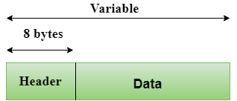
- Transmission Control Protocol (TCP)
  - It provides a full transport layer services to applications.
  - It creates a virtual circuit between the sender and receiver, and it is active for the duration of the transmission.
  - TCP is a reliable protocol as it detects the error and retransmits the damaged frames. Therefore, it ensures all the segments must be received and acknowledged before the transmission is considered to be completed and a virtual circuit is discarded.
  - At the sending end, TCP divides the whole message into smaller units known as segment, and each segment contains a sequence number which is required for reordering the frames to form an original message.
  - At the receiving end, TCP collects all the segments and reorders them based on sequence numbers.

Application Layer
- An application layer is the topmost layer in the TCP/IP model.
- It is responsible for handling high-level protocols, issues of representation.
- This layer allows the user to interact with the application.
- When one application layer protocol wants to communicate with another application layer, it forwards its data to the transport layer.
- There is an ambiguity occurs in the application layer. Every application cannot be placed inside the application layer except those who interact with the communication system. For example: text editor cannot be considered in application layer while web browser using HTTP protocol to interact with the network where HTTP protocol is an application layer protocol.

Following are the main protocols used in the application layer:
- HTTP: HTTP stands for Hypertext transfer protocol. This protocol allows us to access the data over the world wide web. It transfers the data in the form of plain text, audio, video. It is known as a Hypertext transfer protocol as it has the efficiency to use in a hypertext environment where there are rapid jumps from one document to another.
- SNMP: SNMP stands for Simple Network Management Protocol. It is a framework used for managing the devices on the internet by using the TCP/IP protocol suite.
- SMTP: SMTP stands for Simple mail transfer protocol. The TCP/IP protocol that supports the e-mail is known as a Simple mail transfer protocol. This protocol is used to send the data to another e-mail address.
- DNS: DNS stands for Domain Name System. An IP address is used to identify the connection of a host to the internet uniquely. But, people prefer to use the names instead of addresses. Therefore, the system that maps the name to the address is known as Domain Name System.
- TELNET: It is an abbreviation for Terminal Network. It establishes the connection between the local computer and remote computer in such a way that the local terminal appears to be a terminal at the remote system.
- FTP: FTP stands for File Transfer Protocol. FTP is a standard internet protocol used for transmitting the files from one computer to another computer.

PROTOCOLS
In the world of technology, there are vast numbers of users' communicating with different devices in different languages. That also includes many ways in which they transmit data along with the different software they implement. So, communicating worldwide will not be possible if there were no fixed 'standards' that will govern the way user communicates for data as well as the way our devices treat those data. Here we will be discussing these standard set of rules.
Yes, we're talking about "protocols" which are set of rules that help in governing the way a particular technology will function for communication. In other words, it can be said that the protocols are digital languages implemented in the form of networking algorithms. There are different networks and network protocols, user's use while surfing.

Types of Protocols
There are various types of protocols that support a major and compassionate role in communicating with different devices across the network. These are:
- Transmission Control Protocol (TCP)
- Internet Protocol (IP)
- User Datagram Protocol (UDP)
- Post office Protocol (POP)
- Simple mail transport Protocol (SMTP)
- File Transfer Protocol (FTP)
- Hyper Text Transfer Protocol (HTTP)
- Hyper Text Transfer Protocol Secure (HTTPS)
- Telnet
- Gopher
- Transmission Control Protocol (TCP): TCP is a popular communication protocol which is used for communicating over a network. It divides any message into series of packets that are sent from source to destination and there it gets reassembled at the destination.
- Internet Protocol (IP): IP is designed explicitly as addressing protocol. It is mostly used with TCP. The IP addresses in packets help in routing them through different nodes in a network until it reaches the destination system. TCP/IP is the most popular protocol connecting the networks.
- User Datagram Protocol (UDP): UDP is a substitute communication protocol to Transmission Control Protocol implemented primarily for creating loss-tolerating and low-latency linking between different applications.
- Post office Protocol (POP): POP3 is designed for receiving incoming E-mails.
- Simple mail transport Protocol (SMTP): SMTP is designed to send and distribute outgoing E-Mail.
- File Transfer Protocol (FTP): FTP allows users to transfer files from one machine to another. Types of files may include program files, multimedia files, text files, and documents, etc.
- Hyper Text Transfer Protocol (HTTP): HTTP is designed for transferring a hypertext among two or more systems. HTML tags are used for creating links. These links may be in any form like text or images. HTTP is designed on Client-server principles which allow a client system for establishing a connection with the server machine for making a request. The server acknowledges the request initiated by the client and responds accordingly.
- Hyper Text Transfer Protocol Secure (HTTPS): HTTPS is abbreviated as Hyper Text Transfer Protocol Secure is a standard protocol to secure the communication among two computers one using the browser and other fetching data from web server. HTTP is used for transferring data between the client browser (request) and the web server (response) in the hypertext format, same in case of HTTPS except that the transferring of data is done in an encrypted format. So it can be said that https thwart hackers from interpretation or modification of data throughout the transfer of packets.
- Telnet: Telnet is a set of rules designed for connecting one system with another. The connecting process here is termed as remote login. The system which requests for connection is the local computer, and the system which accepts the connection is the remote computer.
- Gopher: Gopher is a collection of rules implemented for searching, retrieving as well as displaying documents from isolated sites. Gopher also works on the client/server principle.

Some Other Protocols
Some other popular protocols act as co-functioning protocols associated with these primary protocols for core functioning. These are:
- ARP (Address Resolution Protocol)
- DHCP (Dynamic Host Configuration Protocol)
- IMAP4 (Internet Message Access Protocol)
- SIP (Session Initiation Protocol)
- RTP (Real-Time Transport Protocol)
- RLP (Resource Location Protocol)
- RAP (Route Access Protocol)
- L2TP (Layer Two Tunnelling Protocol)
- PPTP (Point To Point Tunnelling Protocol)
- SNMP (Simple Network Management Protocol)
- TFTP (Trivial File Transfer Protocol)

Components Of Computer Network:
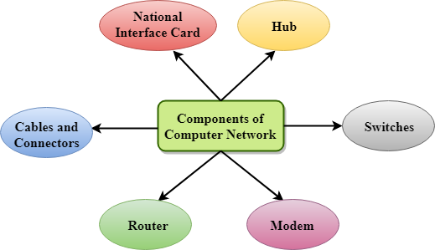

Major components of a computer network are:

NIC(National interface card)
NIC is a device that helps the computer to communicate with another device. The network interface card contains the hardware addresses, the data-link layer protocol use this address to identify the system on the network so that it transfers the data to the correct destination.
There are two types of NIC: wireless NIC and wired NIC.
- Wireless NIC: All the modern laptops use the wireless NIC. In Wireless NIC, a connection is made using the antenna that employs the radio wave technology.
- Wired NIC: Cables use the wired NIC to transfer the data over the medium.

Hub
Hub is a central device that splits the network connection into multiple devices. When computer requests for information from a computer, it sends the request to the Hub. Hub distributes this request to all the interconnected computers.

Switches
Switch is a networking device that groups all the devices over the network to transfer the data to another device. A switch is better than Hub as it does not broadcast the message over the network, i.e., it sends the message to the device for which it belongs to. Therefore, we can say that switch sends the message directly from source to the destination.

Cables and connectors
Cable is a transmission media that transmits the communication signals. There are three types of cables:
- Twisted pair cable: It is a high-speed cable that transmits the data over 1Gbps or more.
- Coaxial cable: Coaxial cable resembles like a TV installation cable. Coaxial cable is more expensive than twisted pair cable, but it provides the high data transmission speed.
- Fibre optic cable: Fibre optic cable is a high-speed cable that transmits the data using light beams. It provides high data transmission speed as compared to other cables. It is more expensive as compared to other cables, so it is installed at the government level.

Router
Router is a device that connects the LAN to the internet. The router is mainly used to connect the distinct networks or connect the internet to multiple computers.

Modem
Modem connects the computer to the internet over the existing telephone line. A modem is not integrated with the computer motherboard. A modem is a separate part on the PC slot found on the motherboard.

Uses Of Computer Network
- Resource sharing: Resource sharing is the sharing of resources such as programs, printers, and data among the users on the network without the requirement of the physical location of the resource and user.
- Server-Client model: Computer networking is used in the server-client model. A server is a central computer used to store the information and maintained by the system administrator. Clients are the machines used to access the information stored in the server remotely.
- Communication medium: Computer network behaves as a communication medium among the users. For example, a company contains more than one computer has an email system which the employees use for daily communication.
- E-commerce: Computer network is also important in businesses. We can do the business over the internet. For example, amazon.com is doing their business over the internet, i.e., they are doing their business over the internet.

Computer Network Types
A computer network is a group of computers linked to each other that enables the computer to communicate with another computer and share their resources, data, and applications.
A computer network can be categorized by their size. A computer network is mainly of four types:
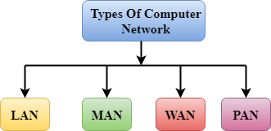
- LAN(Local Area Network)
- PAN(Personal Area Network)
- MAN(Metropolitan Area Network)
- WAN(Wide Area Network)

LAN(Local Area Network)
- Local Area Network is a group of computers connected to each other in a small area such as building, office.
- LAN is used for connecting two or more personal computers through a communication medium such as twisted pair, coaxial cable, etc.
- It is less costly as it is built with inexpensive hardware such as hubs, network adapters, and ethernet cables.
- The data is transferred at an extremely faster rate in Local Area Network.
- Local Area Network provides higher security.
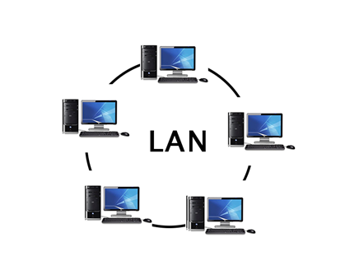

PAN(Personal Area Network)
- Personal Area Network is a network arranged within an individual person, typically within a range of 10 meters.
- Personal Area Network is used for connecting the computer devices of personal use is known as Personal Area Network.
- Thomas Zimmerman was the first research scientist to bring the idea of the Personal Area Network.
- Personal Area Network covers an area of 30 feet.
- Personal computer devices that are used to develop the personal area network are the laptop, mobile phones, media player and play stations.
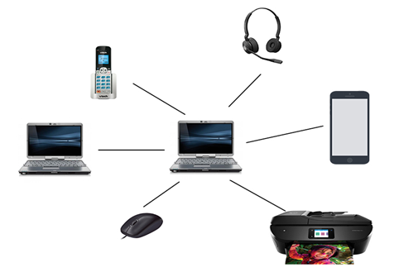
There are two types of Personal Area Network:
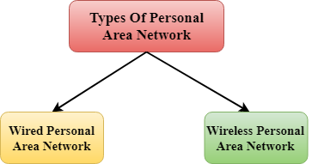
- Wired Personal Area Network
- Wireless Personal Area Network
Wireless Personal Area Network: Wireless Personal Area Network is developed by simply using wireless technologies such as WiFi, Bluetooth. It is a low range network.
Wired Personal Area Network: Wired Personal Area Network is created by using the USB.

Examples Of Personal Area Network:
- Body Area Network: Body Area Network is a network that moves with a person. For example, a mobile network moves with a person. Suppose a person establishes a network connection and then creates a connection with another device to share the information.
- Offline Network: An offline network can be created inside the home, so it is also known as a home network. A home network is designed to integrate the devices such as printers, computer, television but they are not connected to the internet.
- Small Home Office: It is used to connect a variety of devices to the internet and to a corporate network using a VPN

MAN(Metropolitan Area Network)
- A metropolitan area network is a network that covers a larger geographic area by interconnecting a different LAN to form a larger network.
- Government agencies use MAN to connect to the citizens and private industries.
- In MAN, various LANs are connected to each other through a telephone exchange line.
- The most widely used protocols in MAN are RS-232, Frame Relay, ATM, ISDN, OC-3, ADSL, etc.
- It has a higher range than Local Area Network(LAN).
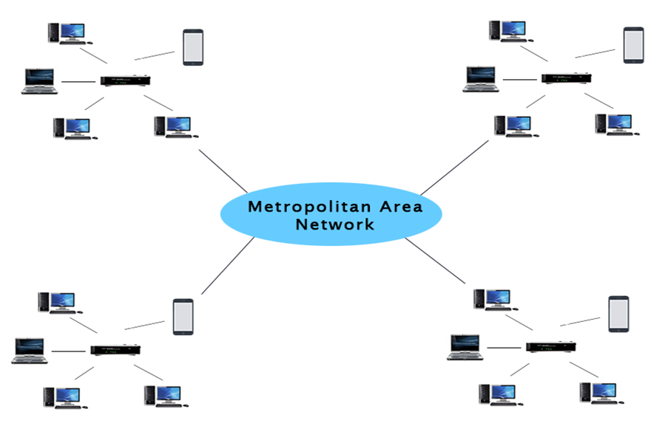

Uses Of Metropolitan Area Network:
- MAN is used in communication between the banks in a city.
- It can be used in an Airline Reservation.
- It can be used in a college within a city.
- It can also be used for communication in the military.

WAN(Wide Area Network)
- A Wide Area Network is a network that extends over a large geographical area such as states or countries.
- A Wide Area Network is quite bigger network than the LAN.
- A Wide Area Network is not limited to a single location, but it spans over a large geographical area through a telephone line, fibre optic cable or satellite links.
- The internet is one of the biggest WAN in the world.
- A Wide Area Network is widely used in the field of Business, government, and education.

What is Topology?
Topology defines the structure of the network of how all the components are interconnected to each other. There are two types of topology: physical and logical topology.
Physical topology is the geometric representation of all the nodes in a network.
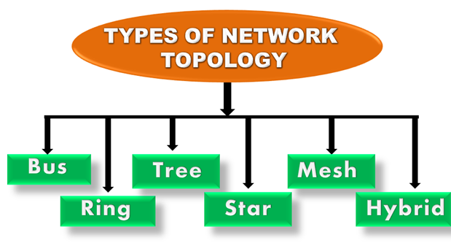

Bus Topology
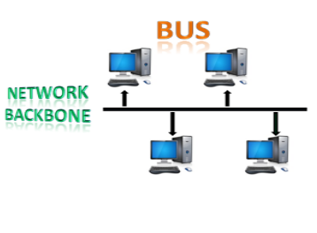
- The bus topology is designed in such a way that all the stations are connected through a single cable known as a backbone cable.
- Each node is either connected to the backbone cable by drop cable or directly connected to the backbone cable.
- When a node wants to send a message over the network, it puts a message over the network. All the stations available in the network will receive the message whether it has been addressed or not.
- The bus topology is mainly used in 802.3 (ethernet) and 802.4 standard networks.
- The configuration of a bus topology is quite simpler as compared to other topologies.
- The backbone cable is considered as a "single lane" through which the message is broadcast to all the stations.
- The most common access method of the bus topologies is CSMA (Carrier Sense Multiple Access).
CSMA: It is a media access control used to control the data flow so that data integrity is maintained, i.e., the packets do not get lost. There are two alternative ways of handling the problems that occur when two nodes send the messages simultaneously.
- CSMA CD: CSMA CD (Collision detection) is an access method used to detect the collision. Once the collision is detected, the sender will stop transmitting the data. Therefore, it works on "recovery after the collision".
- CSMA CA: CSMA CA (Collision Avoidance) is an access method used to avoid the collision by checking whether the transmission media is busy or not. If busy, then the sender waits until the media becomes idle. This technique effectively reduces the possibility of the collision. It does not work on "recovery after the collision".

Advantages of Bus topology:
- Low-cost cable: In bus topology, nodes are directly connected to the cable without passing through a hub. Therefore, the initial cost of installation is low.
- Moderate data speeds: Coaxial or twisted pair cables are mainly used in bus-based networks that support upto 10 Mbps.
- Familiar technology: Bus topology is a familiar technology as the installation and troubleshooting techniques are well known, and hardware components are easily available.
- Limited failure: A failure in one node will not have any effect on other nodes.

Disadvantages of Bus topology:
- Extensive cabling: A bus topology is quite simpler, but still it requires a lot of cabling.
- Difficult troubleshooting: It requires specialized test equipment to determine the cable faults. If any fault occurs in the cable, then it would disrupt the communication for all the nodes.
- Signal interference: If two nodes send the messages simultaneously, then the signals of both the nodes collide with each other.
- Reconfiguration difficult: Adding new devices to the network would slow down the network.
- Attenuation: Attenuation is a loss of signal leads to communication issues. Repeaters are used to regenerate the signal.

Ring Topology
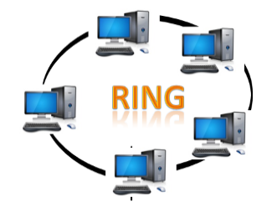
- Ring topology is like a bus topology, but with connected ends.
- The node that receives the message from the previous computer will retransmit to the next node.
- The data flows in one direction, i.e., it is unidirectional.
- The data flows in a single loop continuously known as an endless loop.
- It has no terminated ends, i.e., each node is connected to other node and having no termination point.
- The data in a ring topology flow in a clockwise direction.
- The most common access method of the ring topology is token passing.
  - Token passing: It is a network access method in which token is passed from one node to another node.
  - Token: It is a frame that circulates around the network.

Working of Token passing
- A token moves around the network, and it is passed from computer to computer until it reaches the destination.
- The sender modifies the token by putting the address along with the data.
- The data is passed from one device to another device until the destination address matches. Once the token received by the destination device, then it sends the acknowledgment to the sender.
- In a ring topology, a token is used as a carrier.

Advantages of Ring topology:
- Network Management: Faulty devices can be removed from the network without bringing the network down.
- Product availability: Many hardware and software tools for network operation and monitoring are available.
- Cost: Twisted pair cabling is inexpensive and easily available. Therefore, the installation cost is very low.
- Reliable: It is a more reliable network because the communication system is not dependent on the single host computer.

Disadvantages of Ring topology:
- Difficult troubleshooting: It requires specialized test equipment to determine the cable faults. If any fault occurs in the cable, then it would disrupt the communication for all the nodes.
- Failure: The breakdown in one station leads to the failure of the overall network.
- Reconfiguration difficult: Adding new devices to the network would slow down the network.
- Delay: Communication delay is directly proportional to the number of nodes. Adding new devices increases the communication delay.

Star Topology
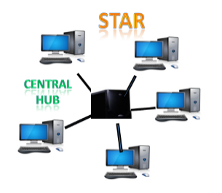
- Star topology is an arrangement of the network in which every node is connected to the central hub, switch or a central computer.
- The central computer is known as a server, and the peripheral devices attached to the server are known as clients.
- Coaxial cable or RJ-45 cables are used to connect the computers.
- Hubs or Switches are mainly used as connection devices in a physical star topology.
- Star topology is the most popular topology in network implementation.

Advantages of Star topology
- Efficient troubleshooting: Troubleshooting is quite efficient in a star topology as compared to bus topology. In a bus topology, the manager has to inspect the kilometers of cable. In a star topology, all the stations are connected to the centralized network. Therefore, the network administrator has to go to the single station to troubleshoot the problem.
- Network control: Complex network control features can be easily implemented in the star topology. Any changes made in the star topology are automatically accommodated.
- Limited failure: As each station is connected to the central hub with its own cable, therefore failure in one cable will not affect the entire network.
- Familiar technology: Star topology is a familiar technology as its tools are cost-effective.
- Easily expandable: It is easily expandable as new stations can be added to the open ports on the hub.
- Cost effective: Star topology networks are cost-effective as it uses inexpensive coaxial cable.
- High data speeds: It supports a bandwidth of approx 100Mbps. Ethernet 100BaseT is one of the most popular Star topology networks.

Disadvantages of Star topology
- A Central point of failure: If the central hub or switch goes down, then all the connected nodes will not be able to communicate with each other.
- Cable: Sometimes cable routing becomes difficult when a significant amount of routing is required.

Tree topology
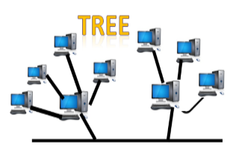
- Tree topology combines the characteristics of bus topology and star topology.
- A tree topology is a type of structure in which all the computers are connected with each other in hierarchical fashion.
- The top-most node in tree topology is known as a root node, and all other nodes are the descendants of the root node.
- There is only one path exists between two nodes for the data transmission. Thus, it forms a parent-child hierarchy.

Advantages of Tree topology
- Support for broadband transmission: Tree topology is mainly used to provide broadband transmission, i.e., signals are sent over long distances without being attenuated.
- Easily expandable: We can add the new device to the existing network. Therefore, we can say that tree topology is easily expandable.
- Easily manageable: In tree topology, the whole network is divided into segments known as star networks which can be easily managed and maintained.
- Error detection: Error detection and error correction are very easy in a tree topology.
- Limited failure: The breakdown in one station does not affect the entire network.
- Point-to-point wiring: It has point-to-point wiring for individual segments.

Disadvantages of Tree topology
- Difficult troubleshooting: If any fault occurs in the node, then it becomes difficult to troubleshoot the problem.
- High cost: Devices required for broadband transmission are very costly.
- Failure: A tree topology mainly relies on main bus cable and failure in main bus cable will damage the overall network.
- Reconfiguration difficult: If new devices are added, then it becomes difficult to reconfigure.

Mesh topology
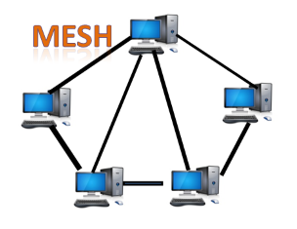
- Mesh technology is an arrangement of the network in which computers are interconnected with each other through various redundant connections.
- There are multiple paths from one computer to another computer.
- It does not contain the switch, hub or any central computer which acts as a central point of communication.
- The Internet is an example of the mesh topology.
- Mesh topology is mainly used for WAN implementations where communication failures are a critical concern.
- Mesh topology is mainly used for wireless networks.
- Mesh topology can be formed by using the formula:
Number of cables = (n*(n-1))/2;
Where n is the number of nodes that represents the network.
Mesh topology is divided into two categories:
- Fully connected mesh topology
- Partially connected mesh topology
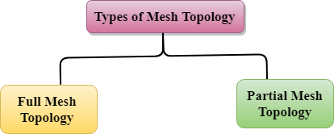
- Full Mesh Topology: In a full mesh topology, each computer is connected to all the computers available in the network.
- Partial Mesh Topology: In a partial mesh topology, not all but certain computers are connected to those computers with which they communicate frequently.

Advantages of Mesh topology:
Reliable: The mesh topology networks are very reliable as if any link breakdown will not affect the communication between connected computers.
Fast Communication: Communication is very fast between the nodes.
Easier Reconfiguration: Adding new devices would not disrupt the communication between other devices.

Disadvantages of Mesh topology
- Cost: A mesh topology contains a large number of connected devices such as a router and more transmission media than other topologies.
- Management: Mesh topology networks are very large and very difficult to maintain and manage. If the network is not monitored carefully, then the communication link failure goes undetected.
- Efficiency: In this topology, redundant connections are high that reduces the efficiency of the network.

Hybrid Topology
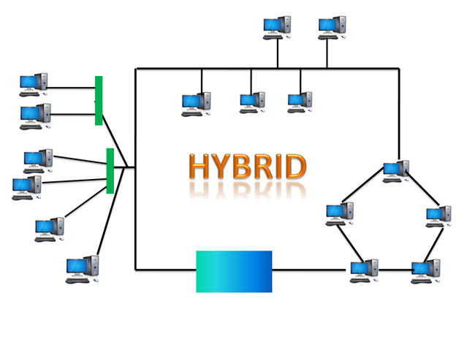
- The combination of various different topologies is known as Hybrid topology.
- A Hybrid topology is a connection between different links and nodes to transfer the data.
- When two or more different topologies are combined together is termed as Hybrid topology and if similar topologies are connected with each other will not result in Hybrid topology. For example, if there exist a ring topology in one branch of ICICI bank and bus topology in another branch of ICICI bank, connecting these two topologies will result in Hybrid topology.

Advantages of Hybrid Topology
- Reliable: If a fault occurs in any part of the network will not affect the functioning of the rest of the network.
- Scalable: Size of the network can be easily expanded by adding new devices without affecting the functionality of the existing network.
- Flexible: This topology is very flexible as it can be designed according to the requirements of the organization.
- Effective: Hybrid topology is very effective as it can be designed in such a way that the strength of the network is maximized and weakness of the network is minimized.

Disadvantages of Hybrid topology
- Complex design: The major drawback of the Hybrid topology is the design of the Hybrid network. It is very difficult to design the architecture of the Hybrid network.
- Costly Hub: The Hubs used in the Hybrid topology are very expensive as these hubs are different from usual Hubs used in other topologies.
- Costly infrastructure: The infrastructure cost is very high as a hybrid network requires a lot of cabling, network devices, etc.

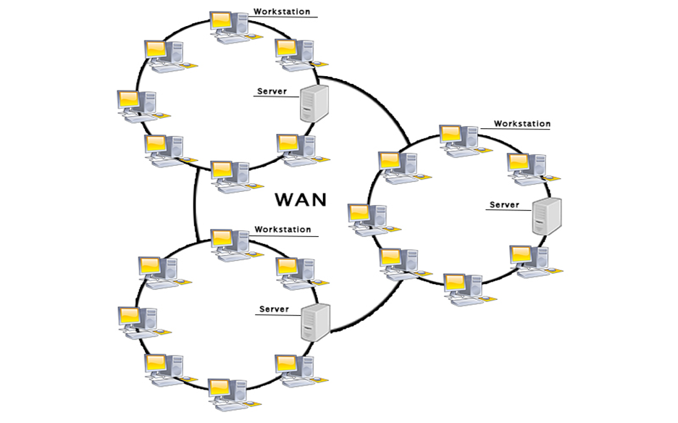

Examples Of Wide Area Network:
- Mobile Broadband: A 4G network is widely used across a region or country.
- Last mile: A telecom company is used to provide the internet services to the customers in hundreds of cities by connecting their home with fiber.
- Private network: A bank provides a private network that connects the 44 offices. This network is made by using the telephone leased line provided by the telecom company.

Advantages Of Wide Area Network:
Following are the advantages of the Wide Area Network:
- Geographical area: A Wide Area Network provides a large geographical area. Suppose if the branch of our office is in a different city then we can connect with them through WAN. The internet provides a leased line through which we can connect with another branch.
- Centralized data: In case of WAN network, data is centralized. Therefore, we do not need to buy the emails, files or back up servers.
- Get updated files: Software companies work on the live server. Therefore, the programmers get the updated files within seconds.
- Exchange messages: In a WAN network, messages are transmitted fast. The web application like Facebook, Whatsapp, Skype allows you to communicate with friends.
- Sharing of software and resources: In WAN network, we can share the software and other resources like a hard drive, RAM.
- Global business: We can do the business over the internet globally.
- High bandwidth: If we use the leased lines for our company then this gives the high bandwidth. The high bandwidth increases the data transfer rate which in turn increases the productivity of our company.

Disadvantages of Wide Area Network:
The following are the disadvantages of the Wide Area Network:
- Security issue: A WAN network has more security issues as compared to LAN and MAN network as all the technologies are combined together that creates the security problem.
- Needs Firewall & antivirus software: The data is transferred on the internet which can be changed or hacked by the hackers, so the firewall needs to be used. Some people can inject the virus in our system so antivirus is needed to protect from such a virus.
- High Setup cost: An installation cost of the WAN network is high as it involves the purchasing of routers, switches.
- Troubleshooting problems: It covers a large area so fixing the problem is difficult.

Internetwork
- An internetwork is defined as two or more computer network LANs or WAN or computer network segments are connected using devices, and they are configured by a local addressing scheme. This process is known as internetworking.
- An interconnection between public, private, commercial, industrial, or government computer networks can also be defined as internetworking.
- An internetworking uses the internet protocol.
- The reference model used for internetworking is Open System Interconnection(OSI).

Types Of Internetwork:
1. Extranet: An extranet is a communication network based on the internet protocol such as Transmission Control protocol and internet protocol. It is used for information sharing. The access to the extranet is restricted to only those users who have login credentials. An extranet is the lowest level of internetworking. It can be categorized as MAN, WAN or other computer networks. An extranet cannot have a single LAN, atleast it must have one connection to the external network.
2. Intranet: An intranet is a private network based on the internet protocol such as Transmission Control protocol and internet protocol. An intranet belongs to an organization which is only accessible by the organization's employee or members. The main aim of the intranet is to share the information and resources among the organization employees. An intranet provides the facility to work in groups and for teleconferences.

Intranet advantages:
- Communication: It provides a cheap and easy communication. An employee of the organization can communicate with another employee through email, chat.
- Time-saving: Information on the intranet is shared in real time, so it is time-saving.
- Collaboration: Collaboration is one of the most important advantage of the intranet. The information is distributed among the employees of the organization and can only be accessed by the authorized user.
- Platform independency: It is a neutral architecture as the computer can be connected to another device with different architecture.
- Cost effective: People can see the data and documents by using the browser and distributes the duplicate copies over the intranet. This leads to a reduction in the cost.

Network Devices (Hub, Repeater, Bridge, Switch, Router, Gateways and Brouter)
1. Repeater – A repeater operates at the physical layer. Its job is to regenerate the signal over the same network before the signal becomes too weak or corrupted so as to extend the length to which the signal can be transmitted over the same network. An important point to be noted about repeaters is that they do not amplify the signal. When the signal becomes weak, they copy the signal bit by bit and regenerate it at the original strength. It is a 2 port device.

2. Hub – A hub is basically a multiport repeater. A hub connects multiple wires coming from different branches, for example, the connector in star topology which connects different stations. Hubs cannot filter data, so data packets are sent to all connected devices. In other words, collision domain of all hosts connected through Hub remains one. Also, they do not have intelligence to find out best path for data packets which leads to inefficiencies and wastage.
Types of Hub
- Active Hub:- These are the hubs which have their own power supply and can clean, boost and relay the signal along with the network. It serves both as a repeater as well as wiring centre. These are used to extend the maximum distance between nodes.
- Passive Hub :- These are the hubs which collect wiring from nodes and power supply from active hub. These hubs relay signals onto the network without cleaning and boosting them and can’t be used to extend the distance between nodes.

3. Bridge – A bridge operates at data link layer. A bridge is a repeater, with add on the functionality of filtering content by reading the MAC addresses of source and destination. It is also used for interconnecting two LANs working on the same protocol. It has a single input and single output port, thus making it a 2 port device.
Types of Bridges
Transparent Bridges:- These are the bridge in which the stations are completely unaware of the
bridge’s existence i.e. whether or not a bridge is added or deleted from the network, reconfiguration of
the stations is unnecessary. These bridges make use of two processes i.e. bridge forwarding and bridge learning.
Source Routing Bridges:- In these bridges, routing operation is performed by source station and the frame specifies which route to follow. The hot can discover frame by sending a special frame called discovery frame, which spreads through the entire network using all possible paths to destination.

4. Switch – A switch is a multiport bridge with a buffer and a design that can boost its efficiency(a large number of ports imply less traffic) and performance. A switch is a data link layer device. The switch can perform error checking before forwarding data, that makes it very efficient as it does not forward packets that have errors and forward good packets selectively to correct port only. In other words, switch divides collision domain of hosts, but broadcast domain remains same.
5. Routers – A router is a device like a switch that routes data packets based on their IP addresses. Router is mainly a Network Layer device. Routers normally connect LANs and WANs together and have a dynamically updating routing table based on which they make decisions on routing the data packets. Router divide broadcast domains of hosts connected through it.
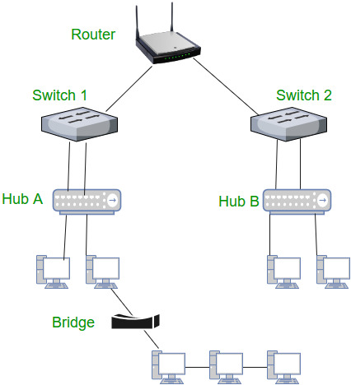

6. Gateway – A gateway, as the name suggests, is a passage to connect two networks together that may work upon different networking models. They basically work as the messenger agents that take data from one system, interpret it, and transfer it to another system. Gateways are also called protocol converters and can operate at any network layer. Gateways are generally more complex than switch or router.

7. Brouter – It is also known as bridging router is a device which combines features of both bridge and router. It can work either at data link layer or at network layer. Working as router, it is capable of routing packets across networks and working as bridge, it is capable of filtering local area network traffic.

SERVICES OF INTERNET -E-mail, FTP, Telnet
Email, discussion groups, long-distance computing, and file transfers are some of the important services provided by the Internet. Email is the fastest means of communication with email one can also send software and certain forms of compressed digital image as an attachment. News groups or discussion groups facilitate Internet user to join for various kinds of debate, discussion and news sharing. Long-distance computing was an original inspiration for development of
ARPANET and does still provide a very useful service on Internet. Programmers can maintain accounts on distant, powerful computers, executive programs. File transfer service allows Internet users to access remote machines and retrieve programs, data or text.

(a) E-Mail (Electronic Mail)
E-mail or Electronic mail is a paperless method of sending messages, notes or letters from one person to another or even many people at the same time via Internet. E-mail is very fast compared to the normal post. E-mail messages usually take only few seconds to arrive at their destination. One can send messages anytime of the day or night, and, it will get delivered immediately. You need not to wait for the post office to open and you don’t have to get worried about holidays. It works 24 hours a day and seven days a week. What’s more, the copy of the message you have sent will be available whenever you want to look at it even in the middle of the night. You have the privilege of sending something extra such as a file, graphics, images etc. along with your e-mail. The biggest advantage of using e-mail is that it is cheap, especially when sending messages to other states or countries and at the same time it can be delivered to a number of people around the world.
It allows you to compose note, get the address of the recipient and send it. Once the mail is received and read, it can be forwarded replied. One can even store it for later use, or delete. In e-mail even the sender can request for delivery receipt and read receipt from the recipient.
(i) Features of E-mail:
One-to-one or one-to-many communicationsλ
Instant communicationsλ
Physical presence of recipient is not requiredλ
Most inexpensive mail services, 24-hours a day and seven days a weekλ
Encourages informal communicationsλ
(ii) Components of an E-mail Address As in the case of normal mail system, e-mail is also based upon the concept of a recipient address. The email address provides all of the information required to get a message to the recipient from any where in the world. Consider the e-mail ID.
abc@hotmail.com
In the above example john is the username of the person who will be sending/receiving the email. Hotmail is the mail server where the username john has been registered and com is the type of organization on the internet which is hosting the mail/ server.

(b) FTP (File Transfer Protocol)
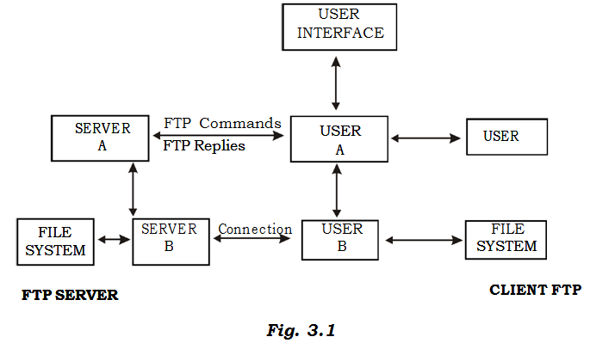
File Transfer Protocol, is an Internet utility software used to uploaded and download files. It gives access to directories or folders on remote computers and allows software, data and text files to be transfer between different kinds of computers. FTP works on the basis of same principle as that of Client/ Server. FTP “Client” is a program running on your computer that enables you to communicate with remote computers. The FTP client takes FTP command and sends these as requests for information from the remote computer known as FTP servers. To access remote FTP server it is required, but not necessary to have an account in the FTP server. When the FTP client gets connected, FTP server asks for the identification in terms of User Login name and password of the FTP client (Fig. 3.1). If one does not have an account in the remote FTP server, still he can connect to the server using anonymous login.
Using anonymous login anyone can login in to a FTP server and can access public archives; anywhere in the world, without having an account. One can easily Login to the FTP site with the username anonymous and e-mail address as password.
(i) Objectives of FTP : Provide flexibility and promote sharing of computer programs, files and dataλ
Transfer data reliably and more efficiently over networkλ
Encourage implicit or indirect use of remote computers using Internetλ
Shield a user from variations in storage systems among hosts.λ
(ii) The basic steps in an FTP session Start up your FTP client, by typing ftp on your system’s command line/’Cλ>’ prompt (or, if you are in a Windows, double-click on the FTP icon).
Give the FTP client an address to connect. This is the FTP server address to which the FTP client will get connected
Identify yourself to the FTP remote site by giving the Login Name
Give the remote site a passwordλ
Remote site will verify the Login Name/Password to allow the FTP client to access its filesλ
Look directory for files in FTP serverλ
Change Directories if requirdλ
Set the transfer mode (optional);λ
Get the file(s) you want, andλ
Quit.λ

(c) Telnet (Remote Computing)
Telnet or remote computing is telecommunication utility software, which uses available telecommunication facility and allows you become a user on a remote computer. Once you gain access to remote computer, you can use it for the intended purpose. The TELNET works in a very step by step procedure. The commands typed on the client computer are sent to the local Internet Service Provider (ISP), and then from the ISP to the remote computer that you have gained access. Most of the ISP provides facility to TELENET into your own account from another city and check your e-mail while you are traveling or away on business.
The following steps are required for a TELNET session
Start up the TELNET program
Give the TELNET program an address to connect (some really nifty TELNET packages allow you to combine steps 1 and 2 into one simple step)
Make a note of what the “escape character” is
Log in to the remote computer,
Set the “terminal emulation”
Play around on the remote computer, and
Quit.

(d)What is Web Conferencing?

Video conferencing or Video teleconferencing is a method of communicating by two-way video and audio transmission with help of telecommunication technologies.
Web Conferencing is an online service by which you can hold live meetings, conferencing, presentations and trainings via the internet particularly on TCP/IP connections. You can connect to the conference either by telephone or using your computer’s speakers and microphone through a VoIP connection.
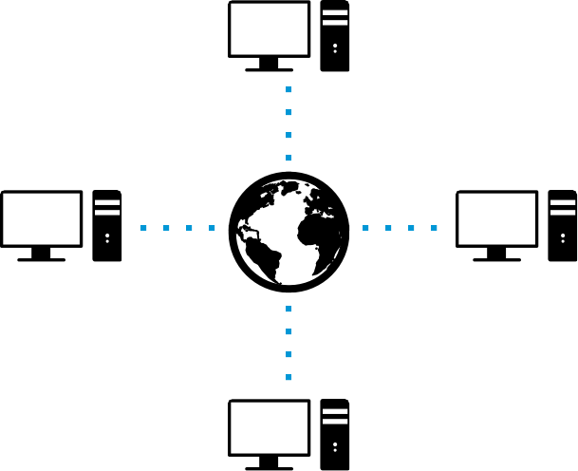
Web conferencing usually allows real time point-to-point communication as well as multi task communications from one sender to many receivers in separate locations. Depending on the service, either an application (additional software) is downloaded and installed or a web-based application is launched in the attendee’s browser. The newest open source technology for Web Conferencing is Google’s WebRTC.

(e) World Wide Web (WWW)
- WWW is also known as W3. It offers a way to access documents spread over the several servers over the internet. These documents may contain texts, graphics, audio, video, hyperlinks. The hyperlinks allow the users to navigate between the documents.
- The development of the World Wide Web was begun in 1989 by Tim Berners-Lee and his colleagues at CERN, an international scientific organization based in Geneva, Switzerland. They created a protocol, HyperText Transfer Protocol (HTTP), which standardized communication between servers and clients. Their text-based Web browser was made available for general release in January 1992.
- World Wide Web, which is also known as a Web, is a collection of websites or web pages stored in web servers and connected to local computers through the internet. These websites contain text pages, digital images, audios, videos, etc. Users can access the content of these sites from any part of the world over the internet using their devices such as computers, laptops, cell phones, etc. The WWW, along with internet, enables the retrieval and display of text and media to your device.
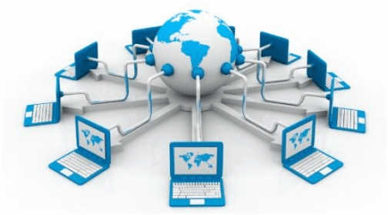
- The building blocks of the Web are web pages which are formatted in HTML and connected by links called "hypertext" or hyperlinks and accessed by HTTP. These links are electronic connections that link related pieces of information so that users can access the desired information quickly. Hypertext offers the advantage to select a word or phrase from text and thus to access other pages that provide additional information related to that word or phrase.
- A web page is given an online address called a Uniform Resource Locator (URL). A particular collection of web pages that belong to a specific URL is called a website, e.g., www.facebook.com, www.google.com, etc. So, the World Wide Web is like a huge electronic book whose pages are stored on multiple servers across the world.
- Small websites store all of their WebPages on a single server, but big websites or organizations place their WebPages on different servers in different countries so that when users of a country search their site they could get the information quickly from the nearest server.
- So, the web provides a communication platform for users to retrieve and exchange information over the internet. Unlike a book, where we move from one page to another in a sequence, on World Wide Web we follow a web of hypertext links to visit a web page and from that web page to move to other web pages. You need a browser, which is installed on your computer, to access the Web.

Difference between World Wide Web and Internet:
Some people use the terms 'internet' and 'World Wide Web' interchangeably. They think they are the same thing, but it is not so. Internet is entirely different from WWW. It is a worldwide network of devices like computers, laptops, tablets, etc. It enables users to send emails to other users and chat with them online. For example, when you send an email or chatting with someone online, you are using the internet.
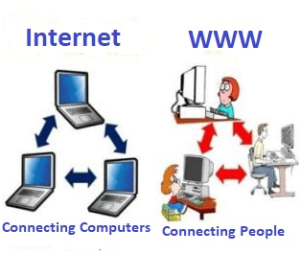
But, when you have opened a website like google.com for information, you are using the World Wide Web; a network of servers over the internet. You request a webpage from your computer using a browser, and the server renders that page to your browser. Your computer is called a client who runs a program (web browser), and asks the other computer (server) for the information it needs.

Chatting
On the Internet, chatting is talking to other people who are using the Internet at the same time you are. Usually, this "talking" is the exchange of typed-in messages requiring one site as the repository for the messages (or "chat site") and a group of users who take part from anywhere on the Internet. In some cases, a private chat can be arranged between two parties who meet initially in a group chat. Chats can be ongoing or scheduled for a particular time and duration.
Most chats are focused on a particular topic of interest and some involve guest experts or famous people who "talk" to anyone joining the chat. (Transcripts of a chat can be archived for later reference.)
Online chat in a less stringent definition may be primarily any direct text-based or video-based (webcams), one-on-one chat or one-to-many group chat (formally also known as synchronous conferencing), using tools such as instant messengers, Internet Relay Chat (IRC), talkers and possibly MUDs.
The expression online chat comes from the word chat which means "informal conversation". Online chat includes web-based applications that allow communication – often directly addressed, but anonymous between users in a multi-user environment.
Web conferencing is a more specific online service, that is often sold as a service, hosted on a web server controlled by the vendor.
The best (and most secure) chat apps
- Facebook Messenger. Facebook's foray into the world of mobile messaging is called Messenger. ...
- WhatsApp. ...
- Telegram. ...
- Signal. ...
- WeChat. ...
- Line. ...
- Skype. ...
- Viber.

Electronic newspaper

An electronic newspaper is a self-contained, reusable, and refreshable version of a traditional newspaper that acquires and holds information electronically. (The electronic newspaper should not be confused with newspapers that offer an online version at a Web site.)
An electronic newspaper is a self-contained, reusable, and refreshable version of a traditional newspaper that acquires and holds information electronically.
Electronic Newspapers India

The Times of India
The Economic Times
Dainik Bhaskar
Hindustan Times
Dainik Jagran
The Indian Express
The Hindu etc..

Online shopping
Online shopping is a form of electronic commerce which allows consumers to directly buy goods or services from a seller over the Internet using a web browser. Consumers find a product of interest by visiting the website of the retailer directly or by searching among alternative vendors using a shopping search engine, which displays the same product's availability and pricing at different e-retailers. As of 2016, customers can shop online using a range of different computers and devices, including desktop computers, laptops, tablet computers and smart phones.
An online shop evokes the physical analogy of buying products or services at a regular "bricks-and-mortar" retailer or shopping center; the process is called business-to-consumer (B2C) online shopping. When an online store is set up to enable businesses to buy from other businesses, the process is called business-to-business (B2B) online shopping. A typical online store enables the customer to browse the firm's range of products and services, view photos or images of the products, along with information about the product specifications, features and prices.
Who provides online shopping?
Most retail stores also have a website that allows their customers to buy from them online and either ship the items to their home or pick up at a nearby store location. Wal-Mart, Best Buy, Sears, and other retail businesses offer this type of shopping experience.Some companies only sell products through their website and do not have a retail storefront. For example, Amazon, Flipkart ,Tiger Direct, Newegg etc conduct their business exclusively online.
Types of internet connectivity
There exist several ways to connect to the internet. Following are these connection types available:
- Dial-up Connection
- ISDN
- DSL
- Cable TV Internet connections
- Satellite Internet connections
- Wireless Internet Connections

Dial-up Connection
Dial-up connection uses telephone line to connect PC to the internet. It requires a modem to setup dial-up connection. This modem works as an interface between PC and the telephone line.
There is also a communication program that instructs the modem to make a call to specific number provided by an ISP.
Dial-up connection uses either of the following protocols:
- Serial Line Internet Protocol (SLIP)
- Point to Point Protocol (PPP)
The following diagram shows the accessing internet using modem:
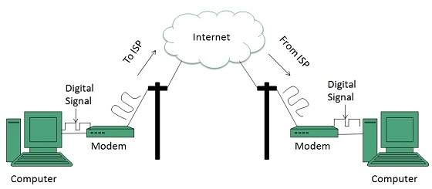

ISDN
ISDN is acronym of Integrated Services Digital Network. It establishes the connection using the phone lines which carry digital signals instead of analog signals.
There are two techniques to deliver ISDN services:
- Basic Rate Interface (BRI)
- Primary Rate Interface (PRI)
Key points:
- The BRI ISDN consists of three distinct channels on a single ISDN line: t1o 64kbps B (Bearer) channel and one 16kbps D (Delta or Data) channels.
- The PRI ISDN consists of 23 B channels and one D channels with both have operating capacity of 64kbps individually making a total transmission rate of 1.54Mbps.
The following diagram shows accessing internet using ISDN connection:
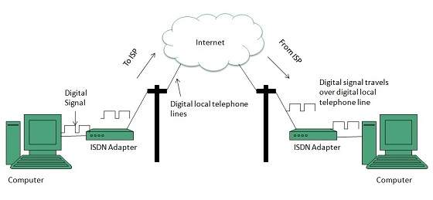

DSL
DSL is acronym of Digital Subscriber Line. It is a form of broadband connection as it provides connection over ordinary telephone lines.
Following are the several versions of DSL technique available today:
- Asymmetric DSL (ADSL)
- Symmetric DSL (SDSL)
- High bit-rate DSL (HDSL)
- Rate adaptive DSL (RDSL)
- Very high bit-rate DSL (VDSL)
- ISDN DSL (IDSL)
All of the above mentioned technologies differ in their upload and download speed, bit transfer rate and level of service.
The following diagram shows that how we can connect to internet using DSL technology:
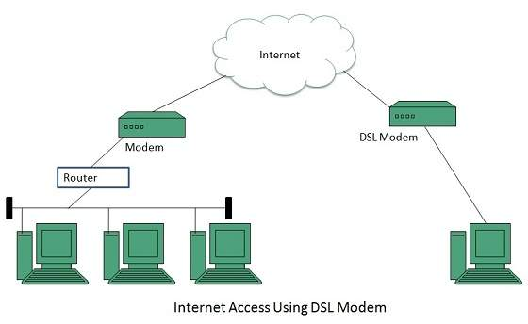

Cable TV Internet Connection
Cable TV Internet connection is provided through Cable TV lines. It uses coaxial cable which is capable of transferring data at much higher speed than common telephone line.
Key Points:
- A cable modem is used to access this service, provided by the cable operator.
- The Cable modem comprises of two connections: one for internet service and other for Cable TV signals.
- Since Cable TV internet connections share a set amount of bandwidth with a group of customers, therefore, data transfer rate also depends on number of customers using the internet at the same time.
The following diagram shows that how internet is accessed using Cable TV connection:
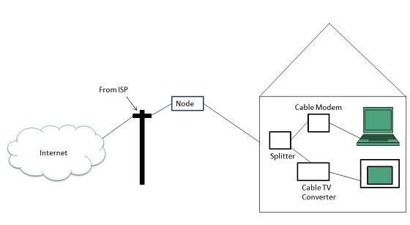

Satellite Internet Connection
Satellite Internet connection offers high speed connection to the internet. There are two types of satellite internet connection: one way connection or two way connection.
In one way connection, we can only download data but if we want to upload, we need a dialup access through ISP over telephone line.
In two way connection, we can download and upload the data by the satellite. It does not require any dialup connection.
The following diagram shows how internet is accessed using satellite internet connection:
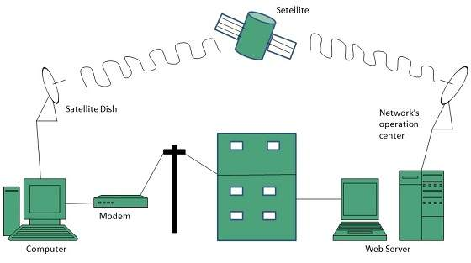

Wireless Internet Connection
Wireless Internet Connection makes use of radio frequency bands to connect to the internet and offers a very high speed. The wireless internet connection can be obtained by either WiFi or Bluetooth.
Key Points:
- Wi Fi wireless technology is based on IEEE 802.11 standards which allow the electronic device to connect to the internet.
- Bluetooth wireless technology makes use of short-wavelength radio waves and helps to create personal area network (PAN).

ISP: Internet Service Provider
- ISP stands for Internet Service Provider. It is a company that provides access to the internet and similar services such as Website designing and virtual hosting. For example, when you connect to the Internet, the connection between your Internet-enabled device and the internet is executed through a specific transmission technology that involves the transfer of information packets through an Internet Protocol route.
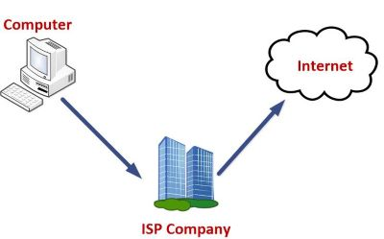
- Data is transmitted through different technologies, including cable modem, dial-up, DSL, high speed interconnects. Accordingly, based on the method of data transmission, the Internet access provided by ISPs can be divided into many types, some of which are as follows:
- Dial-up Internet access: It is the oldest technology to provide Internet access by modem to modem connection using telephone lines. In this method, the user's computer is connected to a modem with a telephone line. This method has become outdated today due to slow connection speed. However, in remote areas, this method can be used where the broadband network is not available.
- DSL: DSL, which stands for 'digital subscriber line' is an advanced version of the dial-up Internet access method. It uses high frequency to execute a connection over the telephone network and allows the internet and the phone connection to run on the same telephone line. This method offers an Asymmetric Digital Subscriber (ADSL), where the upload speed is less than the download speed, and a Symmetric Digital Subscriber Line (SDSL), which offers equal upload and download speeds. Out of these two, ADSL is more popular among users and is popularly known as DSL.
- Wireless Broadband :It is a modern broadband technology for Internet access. It allows high-speed wireless internet within a large area. To use this technology, you are required to place a dish on the top of your house and point it to the transmitter of your Wireless Internet Service Provider (WISP).
- Wi-Fi Internet: It is the short form for "wireless fidelity," which is a wireless networking technology that provides wireless high-speed Internet connections using radio waves. To use the internet, you are required to be within the range of wi-fi network. It is commonly used in public places such as hotels, airports, restaurants to provide internet access to customers.
- ISDN: It is a short form of Integrated Services Digital Network. It is a telephone system network which integrates a high-quality digital transmission of voice and data over the same standard phone line. It offers a fast upstream and downstream Internet connection speed and allows both voice calls and data transfer.
- Ethernet: It is a wired LAN (Local Area Network) where computers are connected within a primary physical space. It enables devices to communicate with each other via a protocol (a set of rules or common network language). It may provide different speeds such as 10 Mbps, 100 Mbps and 10 Gbps.
service providers in India are as follows.
- BSNL. ...
- MTNL. ...
- Bharti Airtel. ...
- Hathway Cable. ...
- Tata Communications. ...
- You Telecom. ...
- Reliance Communications. ...
- Sify Broadband.
- Jio etc…

