NETWORKING LAB MANUAL

Computer Network
A computer network is a group of two or more interconnected computer systems. You can establish a network connection using either cable or wireless media. Every network involves hardware and software that connects computers and tools.

Advantages of a Computer Network
Here are the fundamental benefits of using Computer Networking :
- Helps you to connect with multiple computers together to send and receive information when accessing the network.
- Helps you to share printers, scanners, and email.
- Helps you to share information at very fast speed
- Electronic communication is more efficient and less expensive than without the network.

Computer Network Components :-
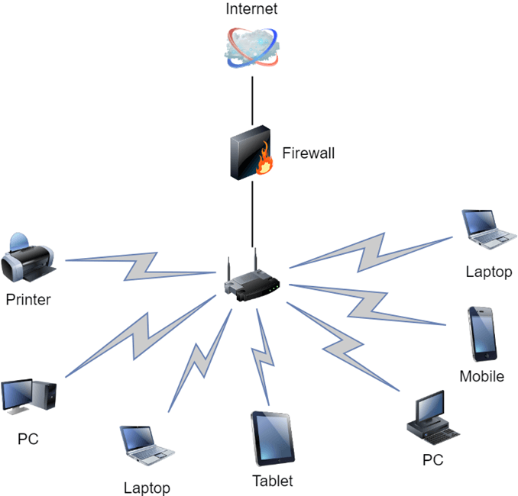

Switches
Switches work as a controller which connects computers, printers, and other hardware devices to a network in a campus or a building.
It allows devices on your network to communicate with each other, as well as with other networks. It helps you to share resources and reduce the costing of any organization.

Routers
Routers help you to connect with multiple networks. It enables you to share a single internet connection with multiple devices and saves money. This networking component acts as a dispatcher, which allows you to analyze data sent across a network. It automatically selects the best route for data to travel and send it on its way.

Servers:
Servers are computers that hold shared programs, files, and the network operating system. Servers allow access to network resources to all the users of the network.

Clients:
Clients are computer devices which access and uses the network as well as shares network resources. They are also users of the network, as they can send and receive requests from the server.

Transmission Media:
Transmission media is a carrier used to interconnect computers in a network, such as coaxial cable, twisted-pair wire, and optical fiber cable. It is also known as links, channels, or lines.

Access points
Access points allow devices to connect to the wireless network without cables. A wireless network allows you to bring new devices and provides flexible support to mobile users.

Shared Data:
Shared data are data which is shared between the clients such as data files, printer access programs, and email.

Network Interface Card:
Network Interface card sends, receives data, and controls data flow between the computer and the network.

Local Operating System:
A local OS which helps personal computers to access files, print to a local printer and uses one or more disk and CD drives which are located on the computer .

Types of Computer Networks
There are various types of computer networks are available. We can categorize them according to their size as well as their purpose.
Network

PAN LAN WAN MAN

PAN (Personal Area Network)
PAN is a computer network formed around a person. It generally consists of a computer, mobile, or personal digital assistant. PAN can be used for establishing communication among these personal devices for connecting to a digital network and the internet.

Characteristics of PAN
- It is mostly personal devices network equipped within a limited area.
- Allows you to handle the interconnection of IT devices at the surrounding of a single user.
- PAN includes mobile devices, tablet, and laptop.
- It can be wirelessly connected to the internet called WPAN.
- Appliances use for PAN: cordless mice, keyboards, and Bluetooth systems.

Advantages of PAN
Here, are important pros/benefits of using PAN network:
- PAN networks are relatively secure and safe
- It offers only short-range solution up to 10 meters
- Strictly restricted to a small area

Disadvantages of PAN
Here are important cons/ drawback of using PAN network:
- It may establish a bad connection to other networks at the same radio bands.
- Distance limits.

LAN (Local Are Network)
A Local Area Network (LAN) is a group of computer and peripheral devices which are connected in a limited area such as school, laboratory, home, and office building. It is a widely useful network for sharing resources like files, printers, games, and other application. The simplest type of LAN network is to connect computers and a printer in someone's home or office. In general, LAN will be used as one type of transmission medium.
It is a network which consists of less than 5000 interconnected devices across several buildings.

Characteristics of LAN
Here are important characteristics of a LAN network:
- It is a private network, so an outside regulatory body never controls it.
- LAN operates at a relatively higher speed compared to other WAN systems.
- There are various kinds of media access control methods like token ring and ethernet.

Advantages of LAN
Here are pros/benefits of using LAN:
- Computer resources like hard-disks, DVD-ROM, and printers can share local area networks. This significantly reduces the cost of hardware purchases.
- You can use the same software over the network instead of purchasing the licensed software for each client in the network.
- Data of all network users can be stored on a single hard disk of the server computer.
- You can easily transfer data and messages over networked computers.
- It will be easy to manage data at only one place, which makes data more secure.
- Local Area Network offers the facility to share a single internet connection among all the LAN users.

Disadvantages of LAN
Here are the important cons/ drawbacks of LAN:
- LAN will indeed save cost because of shared computer resources, but the initial cost of installing Local Area Networks is quite high.
- The LAN admin can check personal data files of every LAN user, so it does not offer good privacy.
- Unauthorized users can access critical data of an organization in case LAN admin is not able to secure centralized data repository.
- Local Area Network requires a constant LAN administration as there are issues related to software setup and hardware failures

WAN (Wider Area Network)
WAN (Wide Area Network) is another important computer network that which is spread across a large geographical area. WAN network system could be a connection of a LAN which connects with other LAN's using telephone lines and radio waves. It is mostly limited to an enterprise or an organization.

Characteristics of WAN:
- The software files will be shared among all the users; therefore, all can access to the latest files.
- Any organization can form its global integrated network using WAN.

Advantages of WAN
Here are the benefits/ pros of using WAN:
- WAN helps you to cover a larger geographical area. Therefore business offices situated at longer distances can easily communicate.
- Contains devices like mobile phones, laptop, tablet, computers, gaming consoles, etc.
- WLAN connections work using radio transmitters and receivers built into client devices.

Disadvantage of WAN
- The initial setup cost of investment is very high.
- It is difficult to maintain the WAN network. You need skilled technicians and network administrators.
- There are more errors and issues because of the wide coverage and the use of different technologies.
- It requires more time to resolve issues because of the involvement of multiple wired and wireless technologies.
- Offers lower security compared to other types of networks.

What is MAN?
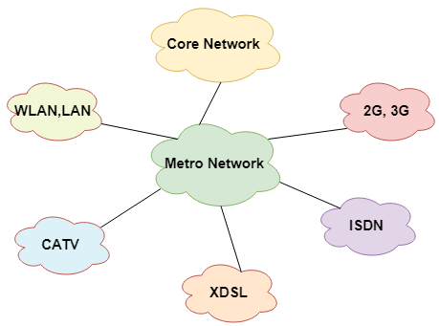
A Metropolitan Area Network or MAN is consisting of a computer network across an entire city, college campus, or a small region. This type of network is large than a LAN, which is mostly limited to a single building or site. Depending upon the type of configuration, this type of network allows you to cover an area from several miles to tens of miles.

Characteristics of MAN
Here are important characteristics of the MAN network:
- It mostly covers towns and cities in a maximum 50 km range
- Mostly used medium is optical fibers, cables
- Data rates adequate for distributed computing applications.

Advantages of MAN
Here are pros/benefits of using MAN system:
- It offers fast communication using high-speed carriers, like fiber optic cables.
- It provides excellent support for an extensive size network and greater access to WANs.
- The dual bus in MAN network provides support to transmit data in both directions concurrently.
- A MAN network mostly includes some areas of a city or an entire city.

Disadvantages of MAN
Here are drawbacks/ cons of using the MAN network:
- You need more cable to establish MAN connection from one place to another.
- In MAN network it is tough to make the system secure from hackers .

Topology
Network topologies describe the methods in which all the elements of a network are mapped. The topology term refers to both the physical and logical layout of a network.

Types of Networking Topologies
Two main types of networking topologies are 1) Physical topology 2) Logical topology
Physical topology:
This type of network is an actual layout of the computer cables and other network devices
Logical topology:
Logical topology gives insight's about network's physical design.
Different types of Physical Topologies are:
- P2P Topology
- Bus Topology
- Ring Topology
- Star Topology
- Tree Topology
- Mesh Topology
- Hybrid Topology

Point to Point
Point-to-point topology is the easiest of all the network topologies. In this method, the network consists of a direct link between two computers.

Advantages:
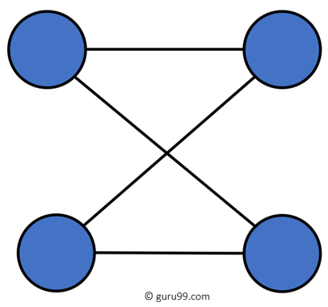
- This is faster and highly reliable than other types of connections since there is a direct connection.
- No need for a network operating system
- Does not need an expensive server as individual workstations are used to access the files
- No need for any dedicated network technicians because each user sets their permissions

Disadvantages:
- The biggest drawback is that it only be used for small areas where computers are in close proximity.
- You can't back up files and folders centrally
- There is no security besides the permissions. Users often do not require to log onto their workstations.

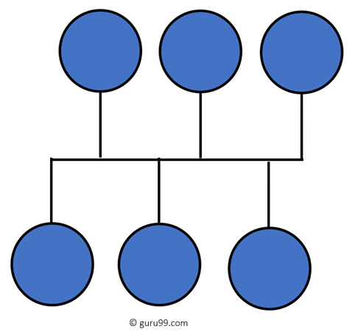
Bus Topology
Bus topology uses a single cable which connects all the included nodes. The main cable acts as a spine for the entire network. One of the computers in the network acts as the computer server. When it has two endpoints, it is known as a linear bus topology.

Advantages:
Here are pros/benefits of using a bus topology:
- Cost of the cable is very less as compared to other topology, so it is widely used to build small networks.
- Famous for LAN network because they are inexpensive and easy to install.
- It is widely used when a network installation is small, simple, or temporary.
- It is one of the passive topologies. So computers on the bus only listen for data being sent, that are not responsible for moving the data from one computer to others.

Disadvantages:
Here are the cons/drawbacks of bus topology:
- In case if the common cable fails, then the entire system will crash down.
- When network traffic is heavy, it develops collisions in the network.
- Whenever network traffic is heavy, or nodes are too many, the performance time of the network significantly decreases.
- Cables are always of a limited length.

Ring Topology
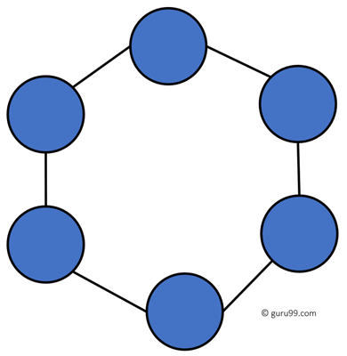
In a ring network, every device has exactly two neighboring devices for communication purpose. It is called a ring topology as its formation is like a ring. In this topology, every computer is connected to another computer. Here, the last node is combined with a first one.
This topology uses token to pass the information from one computer to another. In this topology, all the messages travel through a ring in the same direction.

Advantages:
Here are pros/benefits of ring topology:
- Easy to install and reconfigure.
- Adding or deleting a device in-ring topology needs you to move only two connections.
- The troubleshooting process is difficult in a ring topology.
- Failure of one computer can disturb the whole network.
- Offers equal access to all the computers of the networks
- Faster error checking and acknowledgment.

Disadvantages:
Here are drawbacks/cons of ring topology:
- Unidirectional traffic.
- Break in a single ring can risk the breaking of the entire network
- Modern days high-speed LANs made this topology less popular.
- In the ring, topology signals are circulating at all times, which develops unwanted power consumption.
- It is very difficult to troubleshoot the ring network.
- Adding or removing the computers can disturb the network activity.

Star Topology
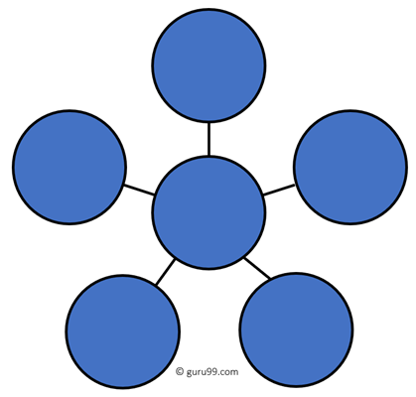
In the star topology, all the computers connect with the help of a hub. This cable is called a central node, and all other nodes are connected using this central node. It is most popular on LAN networks as they are inexpensive and easy to install.

Advantages:
- Easy to troubleshoot, set up, and modify.
- Only those nodes are affected, that has failed. Other nodes still work.
- Fast performance with few nodes and very low network traffic.
- In Star topology, addition, deletion, and moving of the devices are easy.

Disadvantages:

Here are cons/drawbacks of using Star:
- If the hub or concentrator fails, attached nodes are disabled.
- Cost of installation of star topology is costly.
- Heavy network traffic can sometimes slow the bus considerably.
- Performance depends on the hub's capacity
- A damaged cable or lack of proper termination may bring the network down.

Mesh Topology
The mesh topology has a unique network design in which each computer on the network connects to every other. It is develops a P2P (point-to-point) connection between all the devices of the network. It offers a high level of redundancy, so even if one network cable fails, still data has an alternative path to reach its destination.

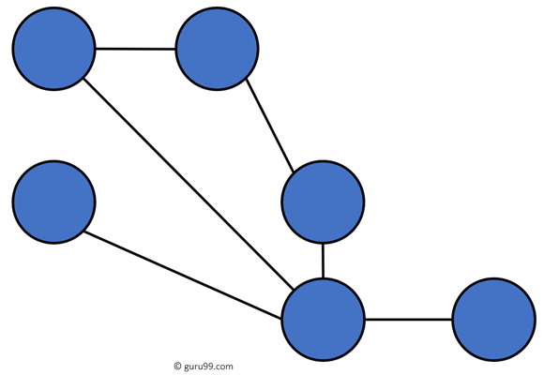
Types of Mesh Topology:

- Partial Mesh Topology: In this type of topology, most of the devices are connected almost similarly as full topology. The only difference is that few devices are connected with just two or three devices.

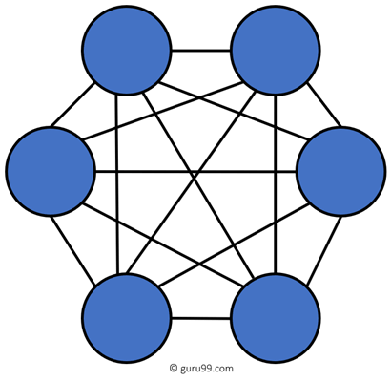
- Full Mesh Topology: In this topology, every nodes or device are directly connected with each other.
Advantages:
Here, are benefits of Mesh topology
- The network can be expanded without disrupting current users.
- Need extra capable compared with other LAN topologies.
- Complicated implementation.
- No traffic problem as nodes has dedicated links.
- It has multiple links, so if any single route is blocked, then other routes should be used for data communication.
- P2P links make the fault identification isolation process easy.
- It helps you to avoid the chances of network failure by connecting all the systems to a central node.

Disadvantages:
- Installation is complex because every node is connected to every node.
- Dedicated links help you to eliminate the traffic problem.
- A mesh topology is robust.
- Every system has its privacy and security
- It is expensive due to the use of more cables. No proper utilization of systems.
- It requires more space for dedicated links.
- Because of the amount of cabling and the number of input-outputs, it is expensive to implement.
- It requires a large space to run the cables.

Tree Topology
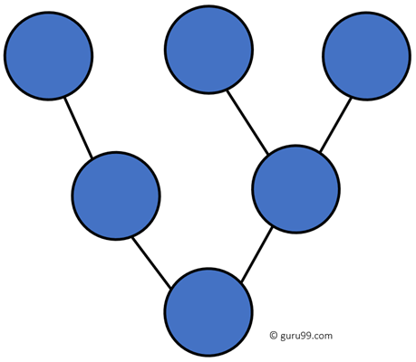
Tree topologies have a root node, and all other nodes are connected which form a hierarchy. So it is also known as hierarchical topology. This topology integrates various star topologies together in a single bus, so it is known as a Star Bus topology. Tree topology is a very common network which is similar to a bus and star topology.

Advantages:
Here are pros/benefits of tree topology:
- Failure of one node never affects the rest of the network.
- Node expansion is fast and easy.
- Detection of error is an easy process
- It is easy to manage and maintain

Disadvantages:
Here are cons/drawback of tree topology:
- It is heavily cabled topology
- If more nodes are added, then its maintenance is difficult
- If the hub or concentrator fails, attached nodes are also disabled.

Hybrid Topology
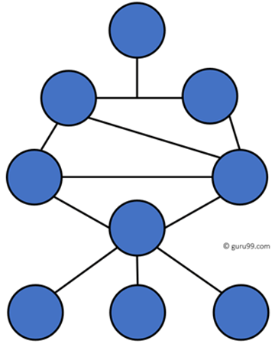
Hybrid topology combines two or more topologies. You can see in the above architecture in such a manner that the resulting network does not exhibit one of the standard topologies.
For example, as you can see in the above image that in an office in one department, Star and P2P topology is used. A hybrid topology is always produced when two different basic network topologies are connected.

Advantages:
Here, are advantages/pros using Hybrid topology:
- Offers the easiest method for error detecting and troubleshooting
- Highly effective and flexible networking topology
- It is scalable so you can increase your network size

Disadvantages:
- The design of hybrid topology is complex
- It is one of the costliest processes

Network Devices
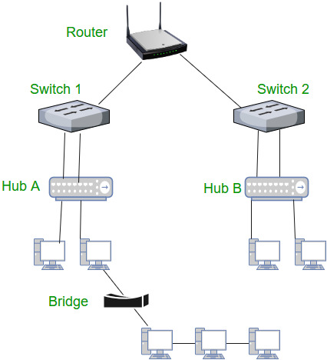

1. Repeater
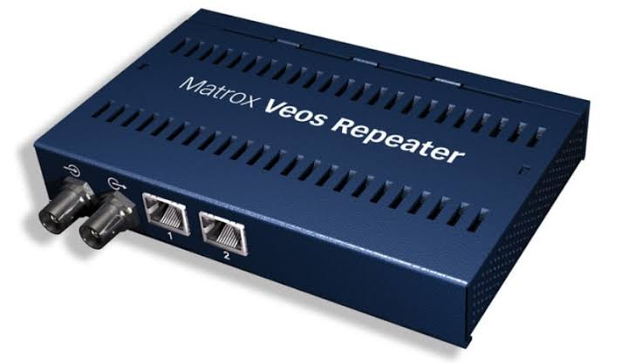
A repeater operates at the physical layer. Its job is to regenerate the signal over the same network before the signal becomes too weak or corrupted so as to extend the length to which the signal can be transmitted over the same network. An important point to be noted about repeaters is that they do not amplify the signal. When the signal becomes weak, they copy the signal bit by bit and regenerate it at the original strength. It is a 2 port device.

2. Hub
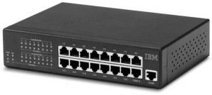
A hub is basically a multiport repeater. A hub connects multiple wires coming from different branches, for example, the connector in star topology which connects different stations. Hubs cannot filter data, so data packets are sent to all connected devices.

Types of Hub
- Active Hub:- These are the hubs which have their own power supply and can clean, boost and relay the signal along with the network. It serves both as a repeater as well as wiring centre. These are used to extend the maximum distance between nodes.
- Passive Hub :- These are the hubs which collect wiring from nodes and power supply from active hub. These hubs relay signals onto the network without cleaning and boosting them and can’t be used to extend the distance between nodes.

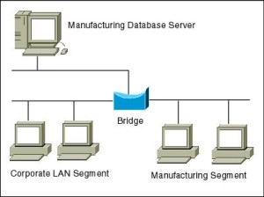
3. Bridge
A bridge operates at data link layer. A bridge is a repeater, with add on the functionality of filtering content by reading the MAC addresses of source and destination. It is also used for interconnecting two LANs working on the same protocol. It has a single input and single output port, thus making it a 2 port device.

4. Switch
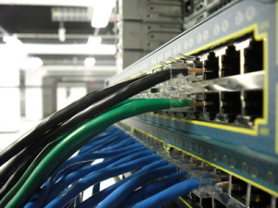
A switch is a multiport bridge with a buffer and a design that can boost its efficiency(a large number of ports imply less traffic) and performance. A switch is a data link layer device. The switch can perform error checking before forwarding data, that makes it very efficient as it does not forward packets that have errors and forward good packets selectively to correct port only. In other words, switch divides collision domain of hosts, but broadcast domain remains same.

5. Routers –
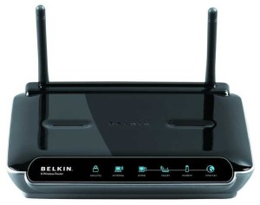

A router is a device like a switch that routes data packets based on their IP addresses. Router is mainly a Network Layer device. Routers normally connect LANs and WANs together and have a dynamically updating routing table based on which they make decisions on routing the data packets. Router divide broadcast domains of hosts connected through it.

6. Gateway –
A gateway, as the name suggests, is a passage to connect two networks together that may work upon different networking models. They basically work as the messenger agents that take data from one system, interpret it, and transfer it to another system. Gateways are also called protocol converters and can operate at any network layer. Gateways are generally more complex than switch or router.

CABLES

Network cables are used to connect two or more computers or networking devices in a network. There are three types of network cables; coaxial, twisted-pair, and fiber-optic.

TYPES OF CABLES
COAXIAL CABLE –
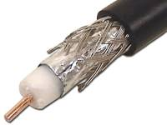
It is a type of electrical cable that has an inner conductor surrounded by a tubular insulating layer, surrounded by a tubular conducting shield. Coaxial cable is a type of transmission line, used to carry high frequency electrical signals with low losses. It is used in such applications as telephone trunk lines, broadband internet networking cables, high speed computer data busses, carrying cable television signals, and connecting radio transmitters & receivers to their antennas.

Twisted Pair :-
Cable has pairs of wires with each pair twisted to eliminate electromagnetic interference and prevent crosstalk; each pair forms a circuit which can transmit data. At each end of the cable RJ-45 connectors are installed, The RJ-45 is an eight-wire connector used commonly to connect computers onto an Ethernet local-area network (LAN).

There are two sub-categories of Twisted Pair Cables as mentioned below
- Unshielded Twisted Pair Cable (UTP)
- Shielded Twisted Pair Cable (STP)
Unshielded Twisted Pair Cable (UTP) :-
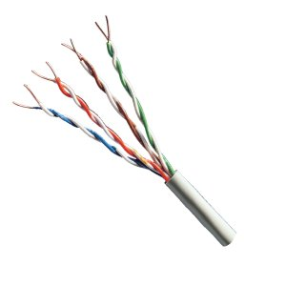
It is the most common type of cable used in networks. Almost all Ethernet LANs are built using UTP cables. UTP cables are thin and flexible and very cost effective which makes them the ideal choice for Ethernet cabling.
Shielded Twisted Pair Cable (STP) :-
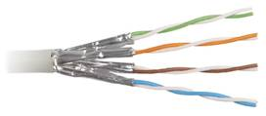
It wraps each pair of wire in a metallic foil and further wraps all four pairs of wires in a metallic braid or foil, this further reduces the noise both within the cable from outside the cable. STP cable is more expensive then UTP cable and is much more difficult to install and manage. It also requires grounding at both ends of the metallic shield.
Fiber-Optic cable :-
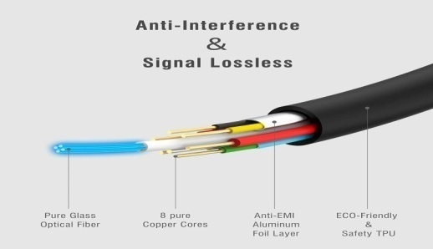
A fiber-optic cable, also known as an optical-fiber cable, is an assembly similar to an electrical cable, but containing one or more optical fibers that are used to carry light. The optical fiber elements are typically individually coated with plastic layers and contained in a protective tube suitable for the environment where the cable will be deployed. Different types of cable^{[1]} are used for different applications, for example, long distance telecommunication, or providing a high-speed data connection between different parts of a building.

Connector
A device that terminates a segment of cabling or provides a point of entry for networking devices such as computers, hubs, and routers. Connectors can be distinguished according to their physical appearance and mating properties, such as jacks and plugs (male connectors) or sockets and ports (female connectors). They can also be distinguished by their different pinning configurations, such as DB9 and DB15 connectors, which have 9 and 15 pins, respectively.
Types of connectors
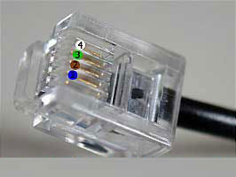
- RJ11 (Registered Jack)
RJ11 was originally designed by phone companies in the 70's and is used for analog voice lines. It is the standard telephone cable connectors, RJ-11 has 4 wires.

RJ-45 (Registered Jack)
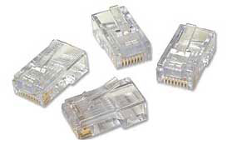
The RJ-45 connector is an eight-wire connector that is commonly used to connect computers to a local area network (LAN), particularly Ethernet LANs. Although they are slightly larger than the more commonly used RJ-11 connectors,

- SC/ ST
SC/ST connectors are used for connecting fiber-optic cabling to networking devices. One is for transmitting data, and one is for receiving data . SC stands for subscriber connector / standard connector and ST stands for straight tip.
SC connector ST connector
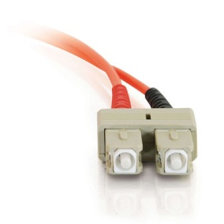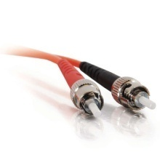

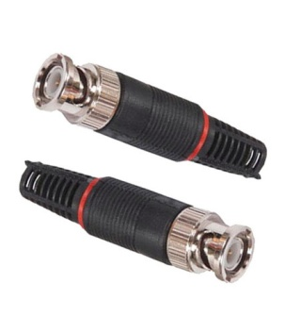
BNC (Bayonet Neill–Concelman)
BNC connectors are attached to the ends of coaxial cables and can be used for connecting signals. On computer monitors, BNC connectors may be used as an alternative to VGA connectors in order to improve the quality of the video. BNC connectors can connect both analog and digital signals.

MAKING CROSS CABLE & STRAIGHT CABLE

Making Straight UTP Cable
- Peel the end of the UTP cable , approximately 2 cm .
- Open the cable strands , align it
- Once the order is according to the standard , cut and flatten the ends of the cable ,
- Put the cable is straight and aligned into the RJ - 45 connector , and make sure all cables are in correct position as follows :
Orange White on no 1
Orange on no 2
Green White on no 3
Blue on no 4
Blue White on no 5
Green on no 6
White Brown on no 7
Brown on no 8
- Make crimping using crimp tool
- Once finished at the end of this one , do it again at the other end cable.

Creating Cross UTP Cable
Creating a cross cable has almost the same steps with straight cable , the difference lies only in the color sequence from both ends of the cable . Unlike the straight cable that has the same color sequence at both ends of the cable , the cross cable has a different color sequences at both ends of the cable .

The first ends is same with straight cable :

For the second end of the cable , the color composition is different from the first . the color arrangement is as follows :
Green White on no. 1
Green on no. 2
Orange White on no. 3
Blue on no. 4
Blue White on no. 5
Orange on no. 6
White chocolate on no. 7
Brown on no. 8

OVERVIEW OF FRONT PANEL & BACK PANEL OF CPU
Front panel
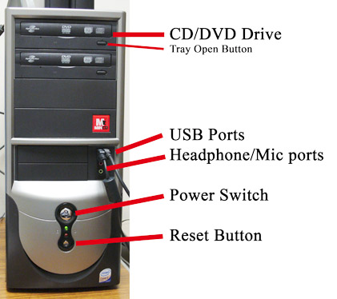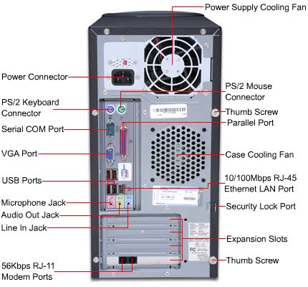

- CD drive - This is the drive where any external CD/DVD can be inserted.
- Floppy disk drive - This the drive where any external floppy can be inserted.
- Power button - It is the button where the power can supply in to the system.
- Reset button – It is to restart the system .
- USB ports – It is used to attach any kbd, mouse, printer, pendrive etc.
- Headphone / Mic port – it is use to attach headphone or speaker.
- Led - It is the indicator which shows the power supply current is going on into the system.

Back panel
- SMPS/Power supply – (switch mode power supply) It is having the 3 pin power connector , to supply AC current in to the system. This unit provides all the electrical power needed by all the components of the computer.
- Power supply cooling Fan – This fan cool the smps.
- PS/2 connector – This is 6 pin female port used to connect kbd and mouse.
- Serial com port – This is 9 pin male port used to connect kbd.
- VGA port – This is 15 pin female port used to connect VGA cable.
- Parallel port – This is 25 pin female port used to connect printer.
- USB port - This port can connect up to 127 peripherals (such as mouse, keyboard, printer, pendrive etc.) at once.
- RJ-45 LAN port – The Ethernet port accepts an Ethernet cable which allows you to communicate on a network that runs transmission control protocol/internet protocol (TCP/IP).
- Audio Jack - Mike in port (pink), Audio/Speaker output (green), Line in port (Blue)
- Expansion slots - An expansion slot is a socket on the motherboard that is used to insert an expansion card (or circuit board), which provides additional features to a computer such as video, sound, advanced graphics, Ethernet or memory.
- RJ 11 – Telephone modem card with RJ-11 female connectors to phone line and telephone. (broad band connection)

TYPES OF SWITCHES, PORTS & CONNECTORS OF CPU
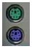 | Keyboard & Mouse : This Port is used to connect keyboard and mouse , now a day we use USB connector for keyboard and mouse
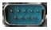 | Serial or COM : It used to connect some types of modem, scanner, or digital camera
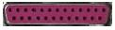 | Parallel or Printer : You plug your printer into the parallel, or printer, port. But now printers may use a USB port
 | USB : Designed to replace older Serial and Parallel ports, the USB (Universal Serial Bus) can connect computers with a number of devices, such as printers, keyboards, mice, scanners, digital cameras, PDAs, and more
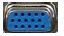 | Video or Monitor : It used to connect your monitor into the video port
 | Line Out : It used to connect speakers or headphone into the Line Out jack
 | Line In : The Line In jack allows you to listen to your computer using a stereo system
 | Microphone : It used to connect a microphone into this jack to record sounds on your computer
 | Joystick or Game : If you have a joystick, musical (MIDI) keyboard, or other gaming device, this is where you plug it in
 | Phone or Modem : The phone or modem jack is where you plug your computer into a phone line
 | Network or Ethernet : You can connect your computer to a network by plugging in an Ethernet cable in this port
 | SCSI : It used to connect a hard drive, CD-ROM drive, or other device to a computer

LAYOUT OF MOTHERBOARD WITH ITS COMPONENTS
Mother Board
A Computer Motherboard is commonly known as Main board or MB or System board or logic board is designed on PCB (Printed Circuit Board).That holds or connects all components and parts together on a single sheet. The Computer Motherboard holds all the circuitry to connect the various components of a computer system. Therefore it is also called as backbone of Personal computer system. The Main board or Motherboard is the main, cruical and important part of the computer system. It holds many important components such as Computer memory slots, cpu, sata IDE slots, expansions slots(PCI,AGP etc),capacitor’s, resistor’s ,BIOS chip etc The Computer main board is made up of thin sheet of non conductive material from plastic.

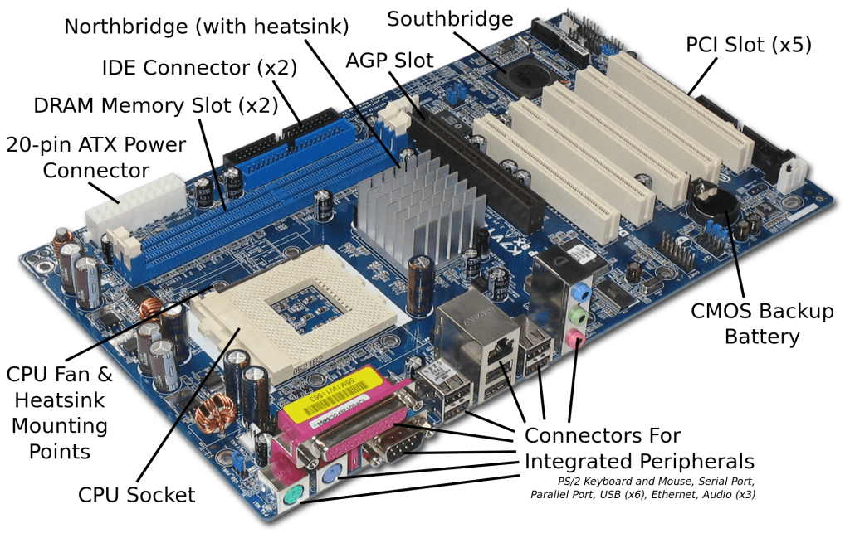

The motherboard may be characterized by the
- Form factor
- Chipset
- Processor socket
Form factor : It refers to the motherboard’s geometry, dimensions, arrangement and electrical requirements. Advanced Technology Extended (ATX) is the most common design of motherboard for desktop computers.
Chipset : It is a circuit, which is used to controls the of resources such as the bus interface with the processor, cache memory and RAM, expansion cards, etc. It used to coordinate data transfers between the various components of the computer.
The processor socket : It is a connector into which the processor is mounted. The Basic Input Output System (BIOS) and Complementary Metal – Oxide semiconductor (CMOS) are present on the motherboard.
Components of Motherboard
- PCI Slot – Thos board has 2 PCI solts. These can be used for components such as Ethernet cards, sound cards, and modems.
- PCI-E 16x Slot – There are 2 of them on this motherboard diagram, both are blue. These are used for your graphics card. With two of them onboard, you can run 2 graphics cards in SLI. You would only need this if you are a gamer, or working with high end video / graphics editing. These are the 16x speed versions, which are currently the fastest.
- PCI-E 1x Slot – Single slot – In the PCI e 1x generation, each lane (1 x) carries 250 MB/s compared to 133 MB/s for the PCI slots. These can be used for expansion cards such as Sound cards, or Ethernet cards.
- Northbridge – This is the Northbridge for this motherboard. This allows communication between the CPU and the system memory and PCI-E slots.
- ATX 12V 2x and 4 Pin power connection – This is one of two power connections that supply power to the motherboard. This connection will come from your Power Supply.
- CPU – Fan Connection – This is where your CPU fan will connect. Using this connection over one from your power supply will allow the motherboard to control the speed of your fan, based on the CPU temperature.
- Socket – This is where your CPU will plug in. The orange bracket that is surrounding it is used for high end heat sinks. It helps to support the weight of the heat sink.
- Memory slots – These are the slots for your RAM. Most boards will have 4 slots, but some will only have 2. The color coding you see on the motherboard diagram is used to match up RAM for Dual-Channel. Using them this way will give your memory a speed boost.
- ATX Power connector – This is the second of two power connections. This is the main power connection for the motherboard, and comes from the power supply.
- IDE connection – The IDE(Integrated Drive Electronics) is the connection for your hard drive or CD / DVD drive. Most drives today come with SATA connections, so you may not use this.
- Southbridge – This is the controller for components such as the PCI slots, onboard audio, and USB connection.
- SATA connections – These are 4 of the 6 SATA connections on the motherboard. These will be used for hard drives, and CD / DVD drives.
- Front Panel connections – This is where you will hook in the connections from your case. These are mostly the different lights on your case, such as power on , hard drive activity etc.
- FDD connection – The FDD is the floppy Disk controller. If you have a floppy disk drive in your computer, this is where you will hook it up.
- External USB connections – This is where you will plug in external USB connections for your case or USB bracket.
- CMOS battery – This is the motherboard’s battery. This is used to allow the CMOS to keep it settings.

INSTALL NETWORK INTERFACE CARD
- Power down your PC and unplug it. Remove the screws holding the sides of the case on and slowly slide off both the panels.
- Locate an empty PCI slot and remove the metal backing plate by taking out the screws holding it by slowly sliding it up and out. Do this with the help of flat-blade screw driver
- Remove the network terface card from its anti-static bag and place it over the slot with the jack facing outside the PC.
- Firmly press down the NIC such that the mounting bracket is properly aligned with the slot. Gently rock the card from end to end to secure it in the slot so that the gold contacts at the bottom of the NIC disappears totally in the slot. The card should be even and straight.
- Replace the NIC mounting bracket to the case with a screw and plug your machine back in. Plug in the Ethernet wire to the RJ-45 jack and the other end into the DSL modem, hub, router or directly to another PC. This finishes the hardware installation.
The NIC comes with a disk containing the necessary drivers required for the software installation. Just install the driver software into the system.
CONFIGURE NETWORK INTERFACE CARD
- Open the Control Panel.
- Set View by to Category.
- Click Network and Internet.
- Click Network and Sharing Center.
- On the left pane, click Change adapter settings.
- Right-click the local area network connection that is connected to the radio hardware and select Properties.
  - If an unused network connection is available, the local area connection appears as Unidentified network.
  - If you plan to reuse your network connection, select the local area connection that you plan to use for the radio hardware.
  - If you have only one network connection, check if you can connect wirelessly to the existing local area network. If you can, you can use the network connection for the radio hardware.
  - You can use a pluggable USB to Gigabit Ethernet LAN adapter instead of a NIC. The instructions are the same.
- On the Networking tab of the Properties dialog box, clear all options except Internet Protocol Version 4 (TCP/IPv4). Other services, particularly antiviral software, can cause intermittent connection problems with the radio hardware.
- Double-click Internet Protocol Version 4 (TCP/IPv4).
- On the General tab, select Use the following IP Address.
- The default IP address is 192.168.1.101. The development computer network connection must be on the same subnet as the hardware board. To meet this requirement, a compatible IP address must be assigned to the development computer network connection. Set the network IP address to 192.168.1.x, where x is any number in the range 1 through 255, apart from 101.
- Leave the subnet mask set to the default value of 255.255.255.0 and click OK.

IDENTIFY THE IP ADDRESS & CONFIGURE IP ADDRESS
How to set IP
Most computers that are attached to an Ethernet network will have their IP addresses assigned automatically by DHCP.
- Open the Network and Sharing Center window.
- On the right side of the window, choose the link Local Area Connection.
- In the Status dialog box, click the Properties button.
A Properties dialog box for the connection appears. It lists the various protocols and services being used by the connection.
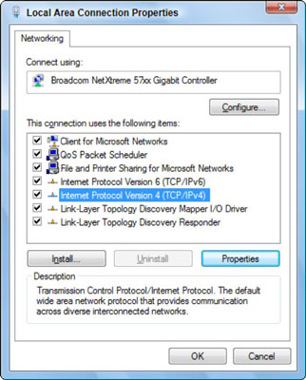
- Select the service titled Internet Protocol Version 4 (TCP/IPv4).
- Click the Properties button.
The dialog box labeled Internet Protocol Version 4 (TCP/IPv4) Properties appears.
- Choose the option Use the Following IP Address.
- Type the IP address.
- At this point, you must know what you’re doing. Seriously. Typing an improper IP address, or one that’s out of range, means that your computer cannot use the network.
- Type a subnet mask.
For a local-area network, the value is usually 255.255.255.0, but it could be something else depending on the specifics of your network.
- Type the default gateway address. The default gateway address is the IP address for the network’s router.
Because DHCP also obtains the address for the DNS server, which helps your computer find addresses on the Internet, you need to manually list those addresses as well.
- Type the address of the preferred DNS server. This value is obtained from your ISP.
- Type the address for the alternative DNS server. The alternate DNS server’s IP address is also something that your ISP must provide.
- Click OK to close the Internet Protocol Version 4 (TCP/IPv4) Properties dialog box.
- Close the other open dialog boxes and windows.

MANAGING USER A/C IN WINDOWS
To go to your user accounts:
- Go to the Control Panel from the Start Menu.
- Click Add or remove user accounts. Going to user accounts.
- The Manage Accounts pane will appear. You will see all of the user accounts here, and you can add more accounts or manage existing ones. The Manage Accounts pane.

CONNECTIVITY TROUBLESHOOTING USING PING /IPCONFIG

network troubleshooting tools necessity for every network administrator when getting started in the network field,
It is important to a mass and number of tools that can be used to troubleshoot a variety of different network conditions.

PING

The ping command allows you to send a signal to another device ,and if that device is active, it will send a response back to the sender. The “Ping” command is a subset of the ICMP (internet control message protocol) and it uses what it called an “echo request”. So when you ping a device you send out an “echo request” , and if the device you Ping is active or online you get an echo response.

For example if you are local computer has internet connectivity issues, you can try to ping your router. If you get no response then you know that the router is what is giving you problems. Let's ping our router IP, which is reaches 192.168 router IP reaches 192.168 our router IP reaches 192.168 router IP reaches 192.168. 8.1 is our example and let's analyze the printout.
IPConfig
The IP config display the current information about your network such as IP and MAC address, and the IP address of your router. It can also display information about your DHCP and DNS servers. Let's see the basic output of “IPconfig”. Depending on the network connection type you may see different output for different connection. For example if you are connected to the network using Ethernet (you plug in your network cable to the RJ45 Jack) you will see IP information in the “Ethernet adaptor” section. In our case we are connected to the Wi-Fi (wireless) connection so get information there in our case. The local IPV4 of a computer is 192 168 8.103. We also see the subnet mask (255.255.255.0) which we can use to find the network address. We also see the default gateway IP (192.168.8.1) which is our router.

